Standard Operating Procedure (SOP)
Warranty and Claim (JC Insurance)

- Login to Salesforce using credentials.
- Procced creating the same process as mentioned in Job Card process
- In service details section select job card type as Accidental Repais
- Enter valid OTP and validate

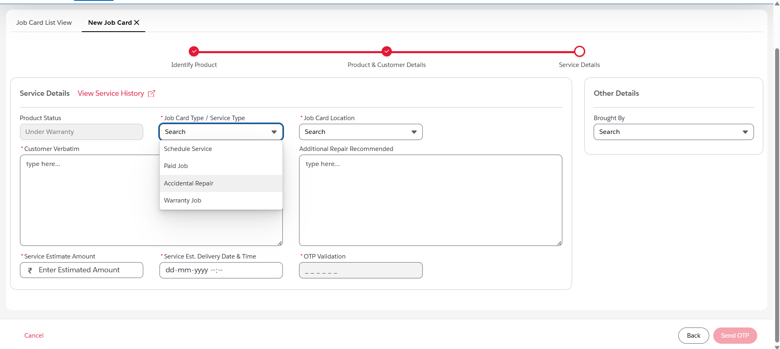

Once Job Card is created click on Assign Technician
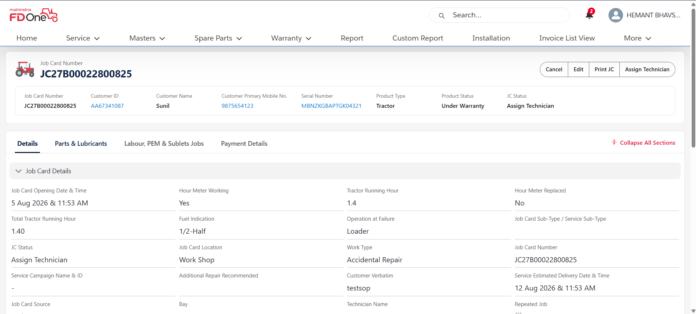

Select technician details and click on assign technician

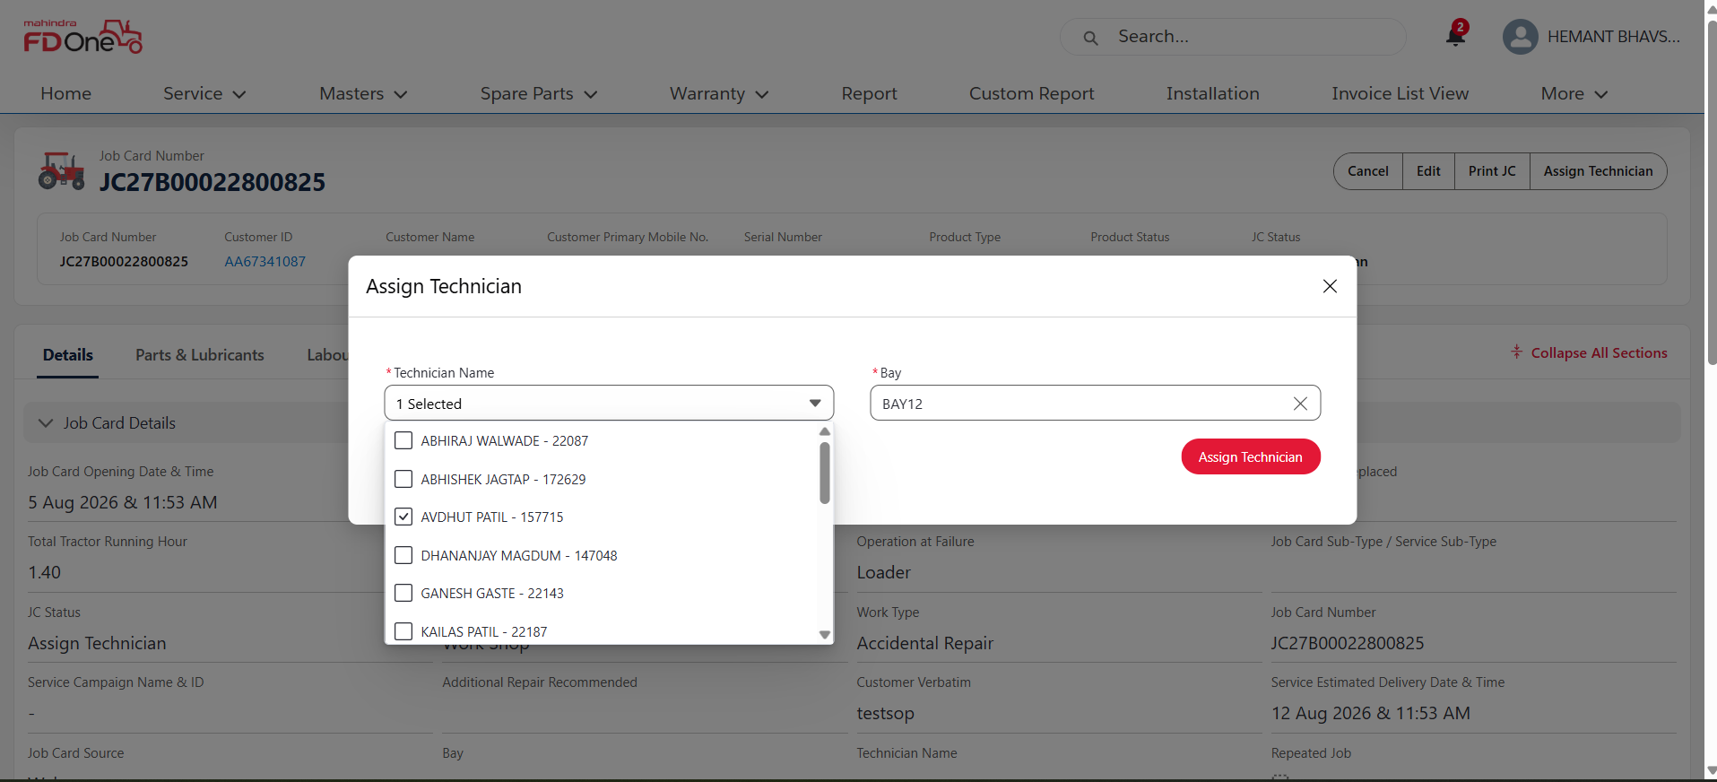

Add Parts, Labour which is required and click on Close JC
Enter Physical JC number and continue to close the job card

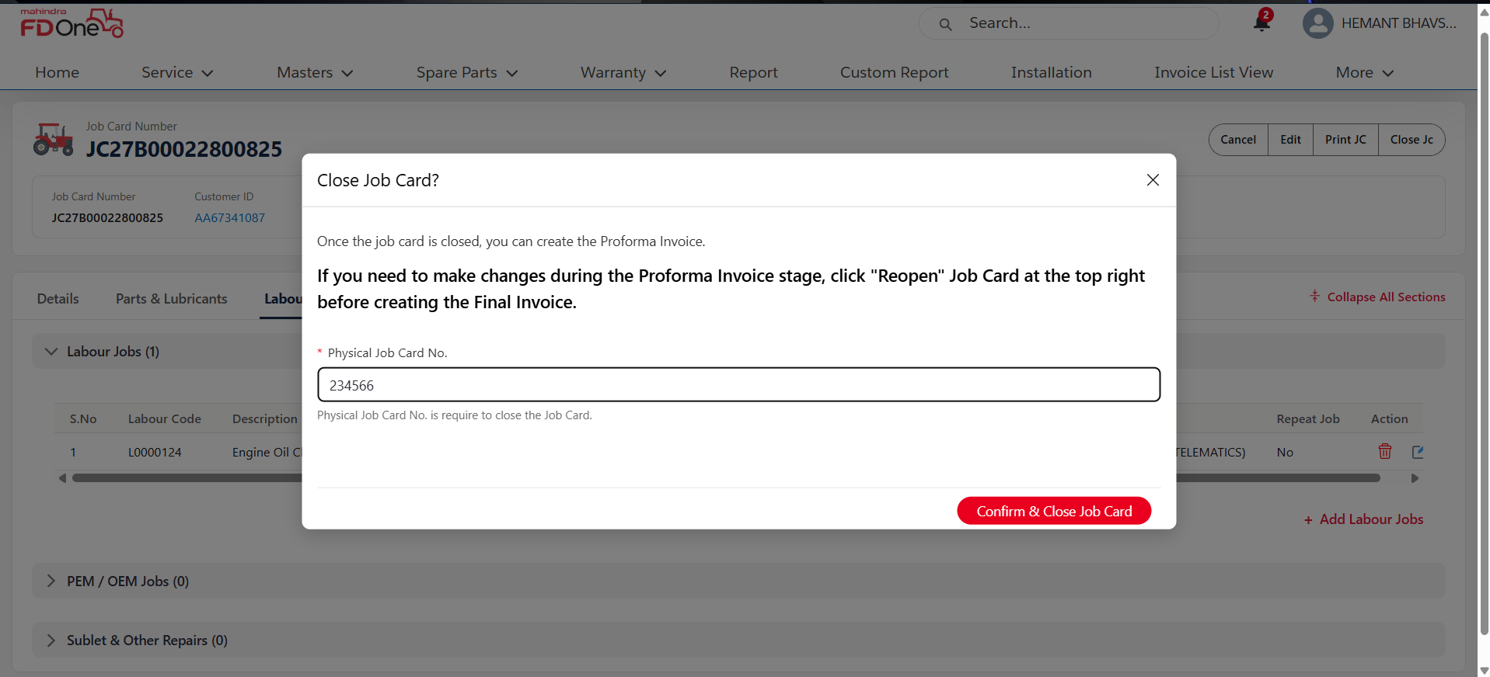

Click on create Proforma Invoice
Select Bill To details as Insurance Company

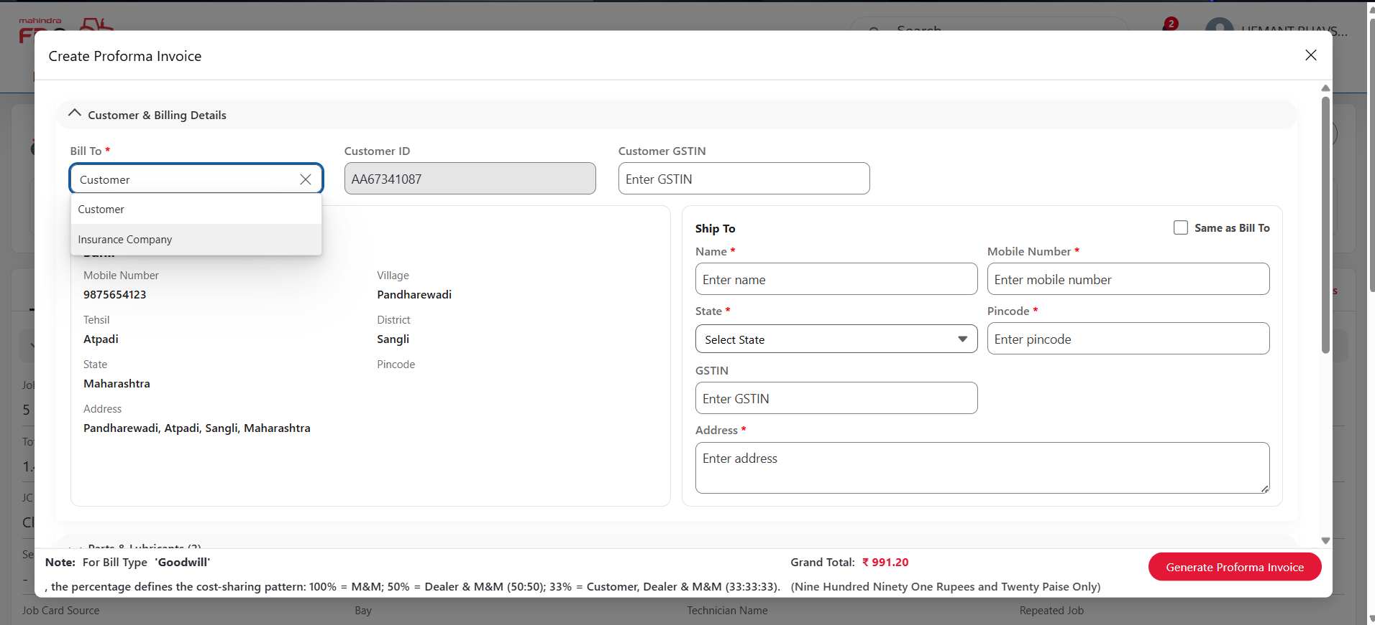
Select Insurance Company details as given below in the screenshot

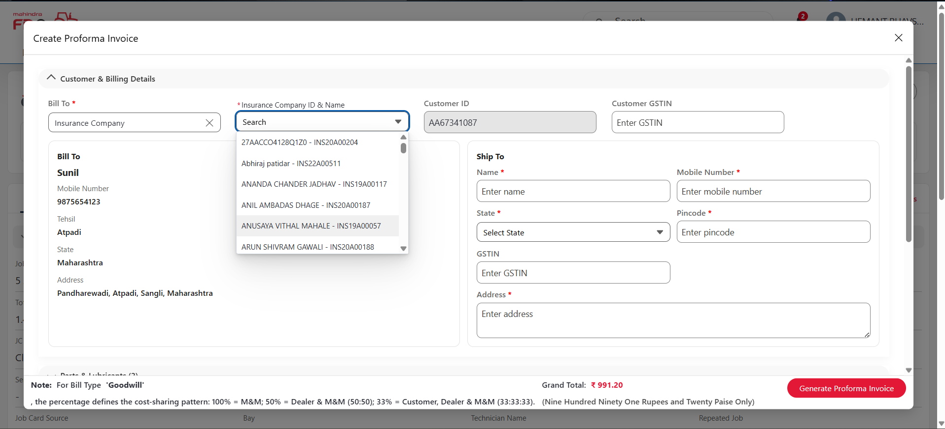

Select Bill Type as Free before proceeding to generate proforma Invoice

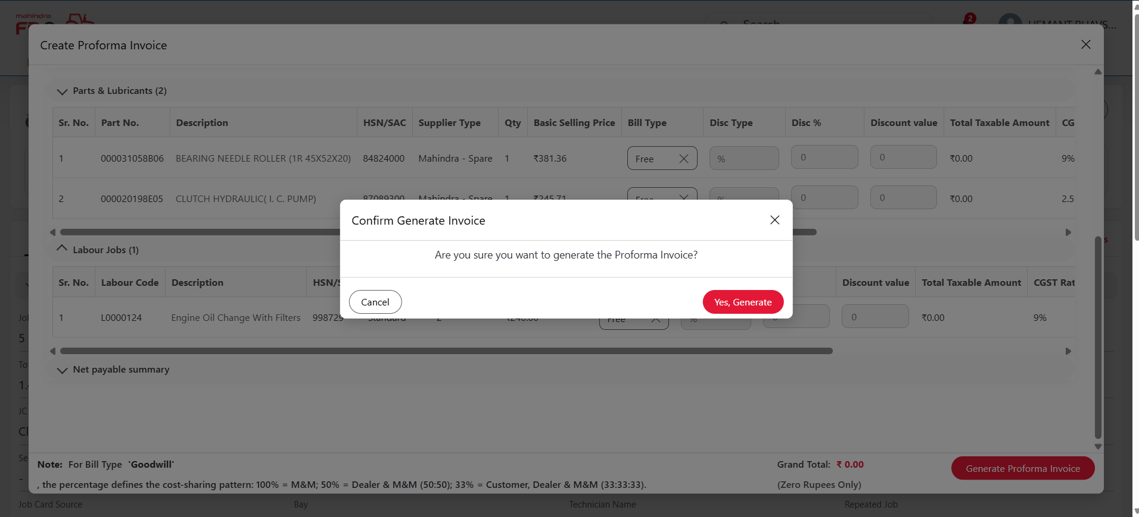

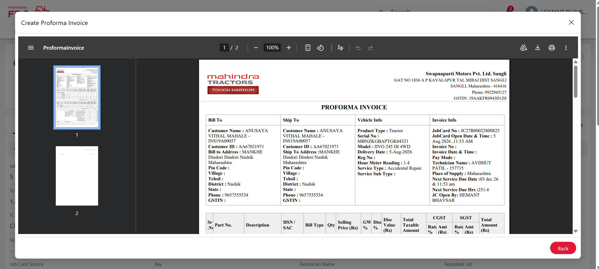

Proforma Invoice is generated and gets routed to Insurance Company.

