Standard Operating Procedure (SOP)
Installation Process

- Login to Salesforce using credentials.
- Click on the Installation Tab
- Below is list view of Installation Dashboard
- To Perform Installation, Click on Pending Records tab

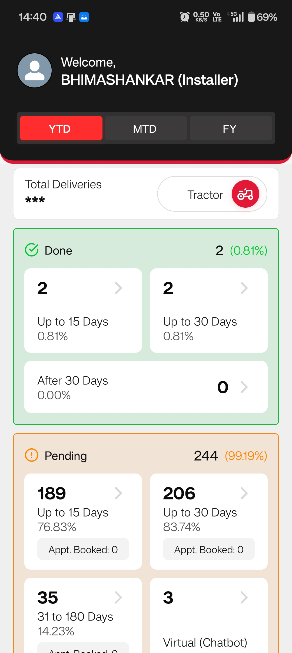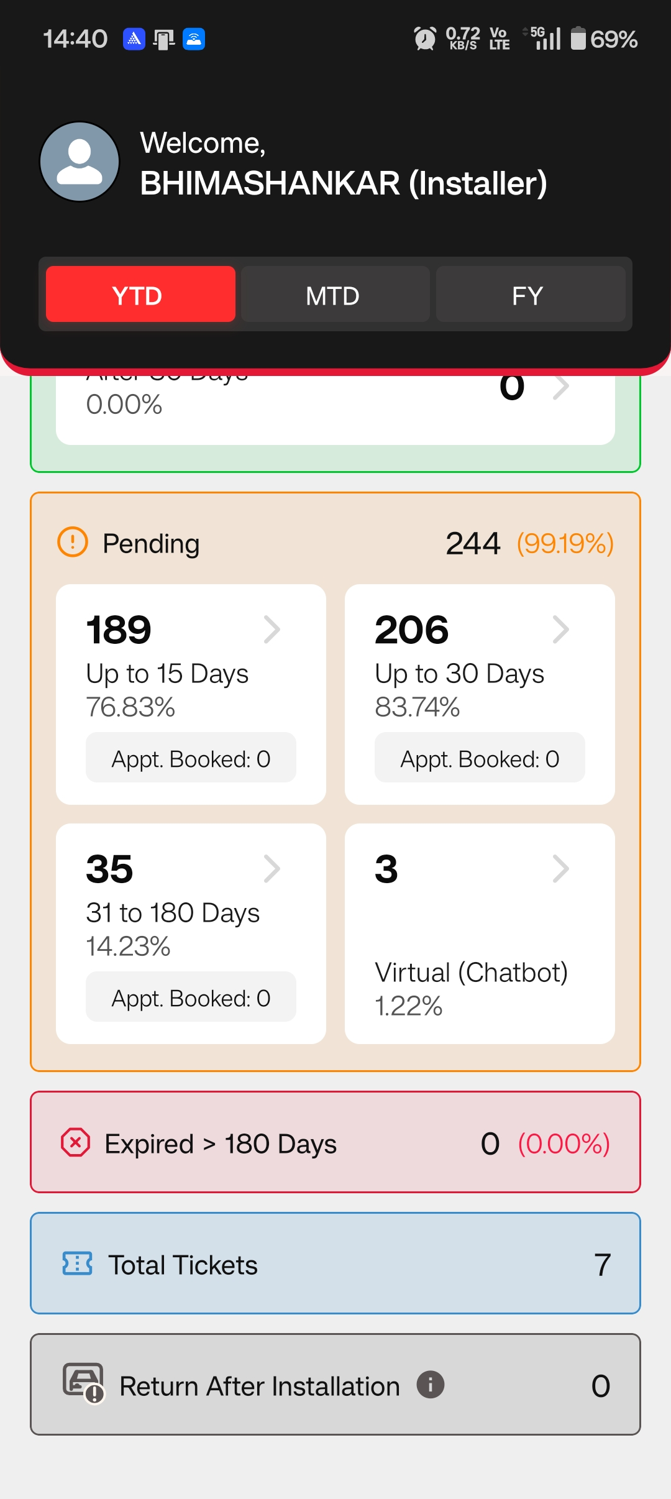
Below is the List view of Records which needs to be performed by Installer
Installer can either call the customer to check the availability and book an appointment
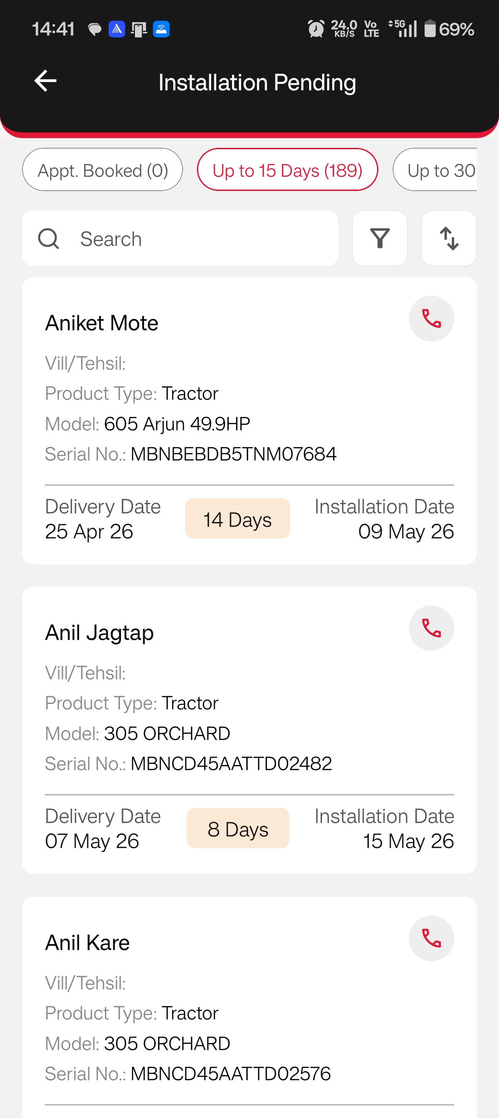
Appointment Booking

- Click on any one of the Record to book an appointment
- Click on book appointment and select suitable date and time based on customer’s confirmation
- Once the appointment is booked Installer can able to see Options to Reschedule/Cancel if customer is not available
- Installer can also raise a Ticket by clicking on Raise a Ticket Button if He faces any issue to perform the Installation
- Once ticket is raised the ticket gets assigned to dealer Team (Dealer CEO) login over the Web and Can take action against the Ticket
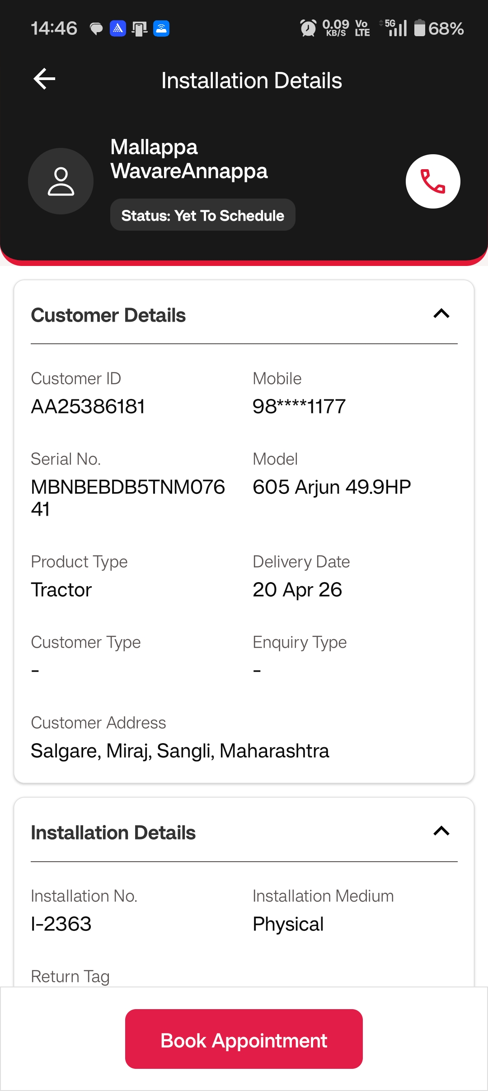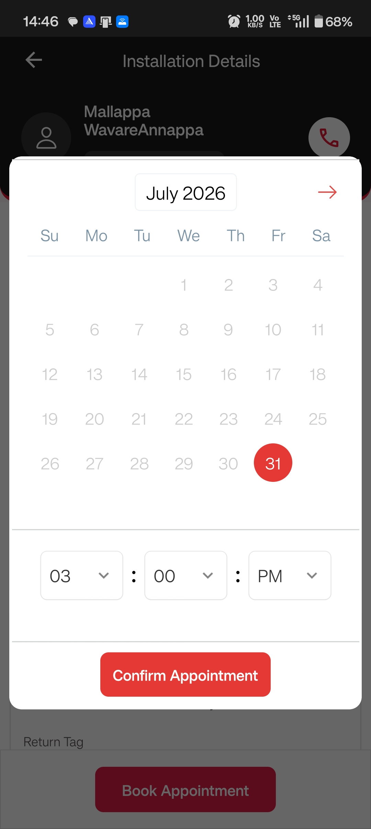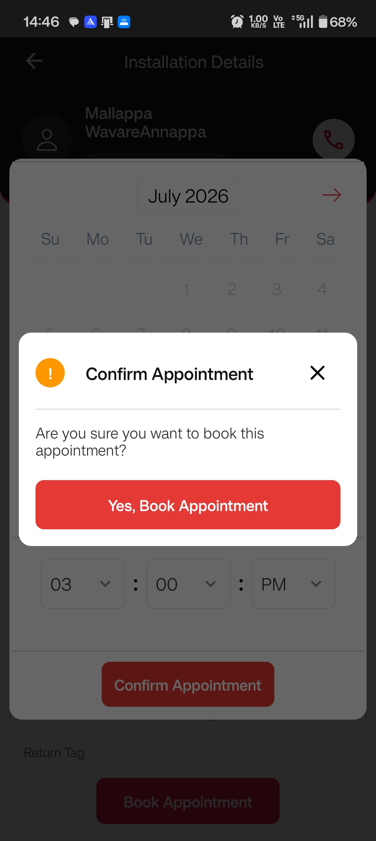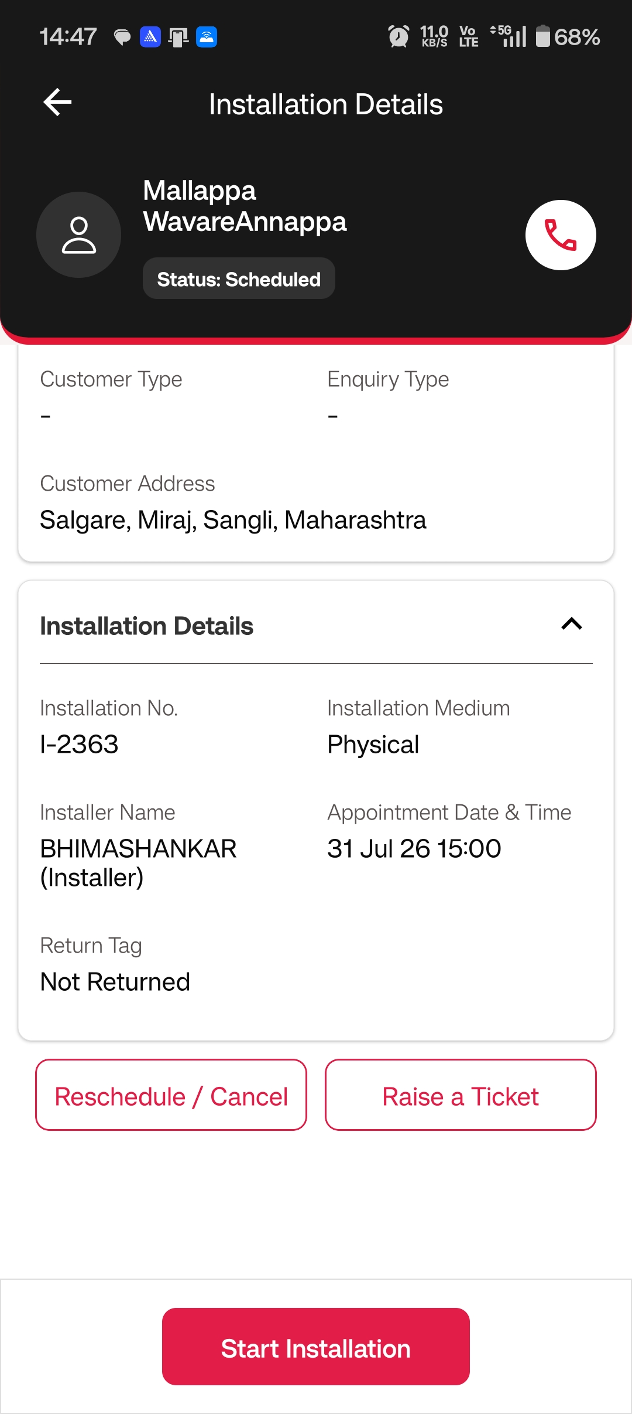
Immediately once the Installation is booked the record will be visible under Appointment Booked Section
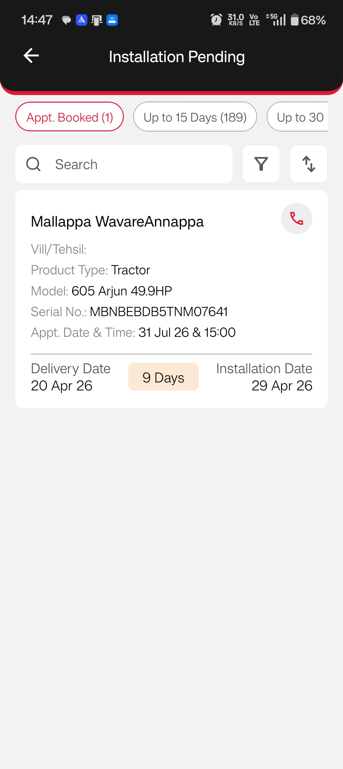

Reschedule Appointment: When Installer clicks on Reschedule Appointment below screens will get displayed to reselect Time and Date on which Installation needs to be performed
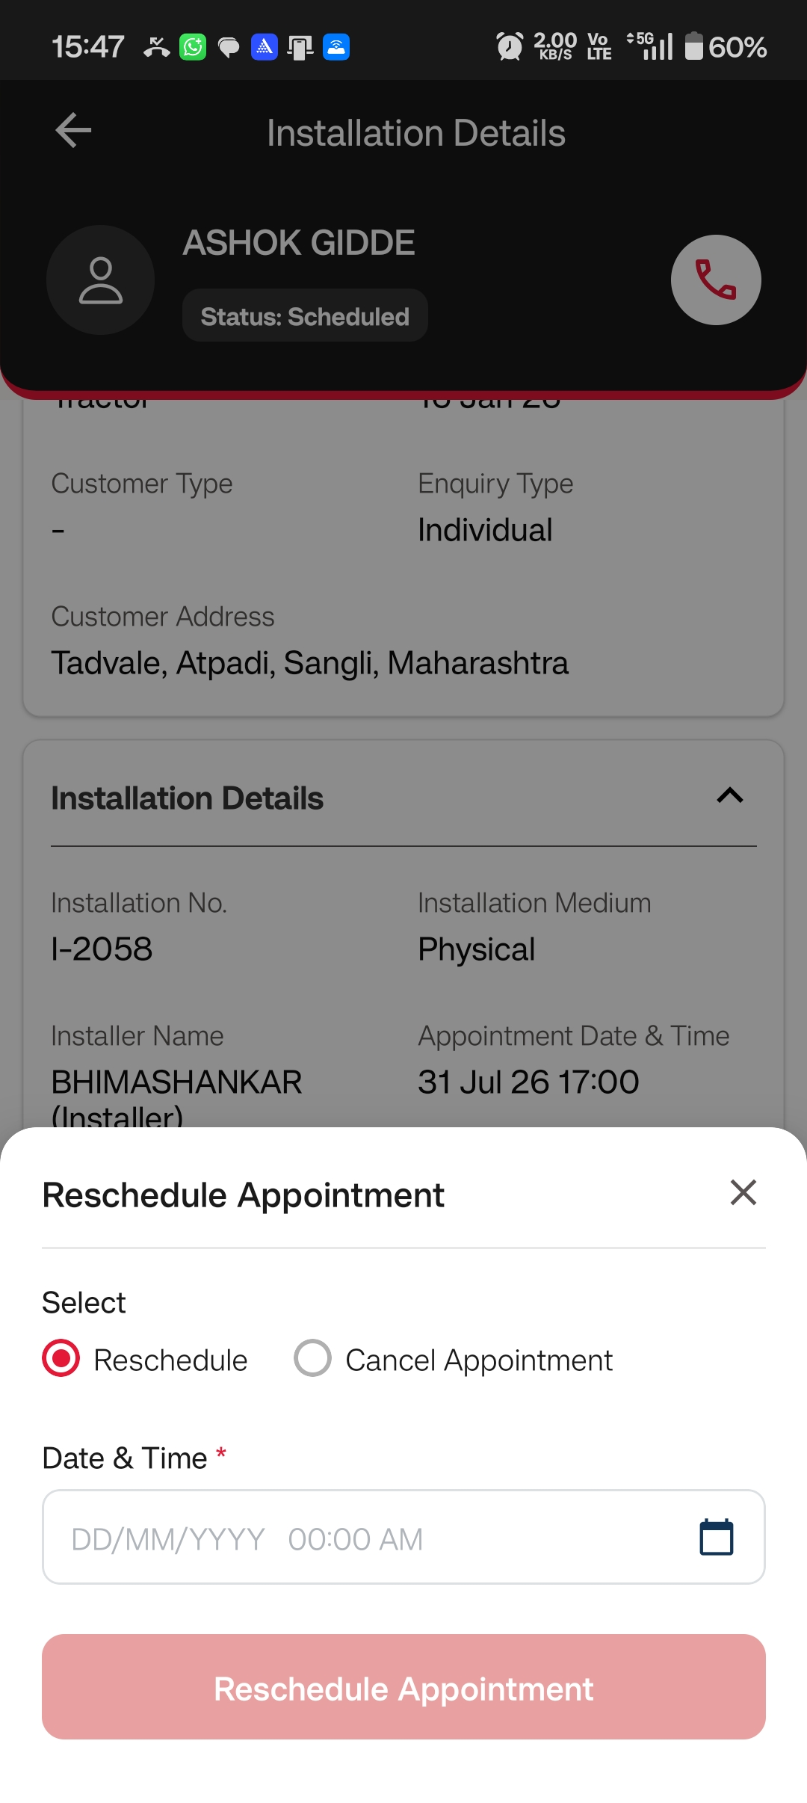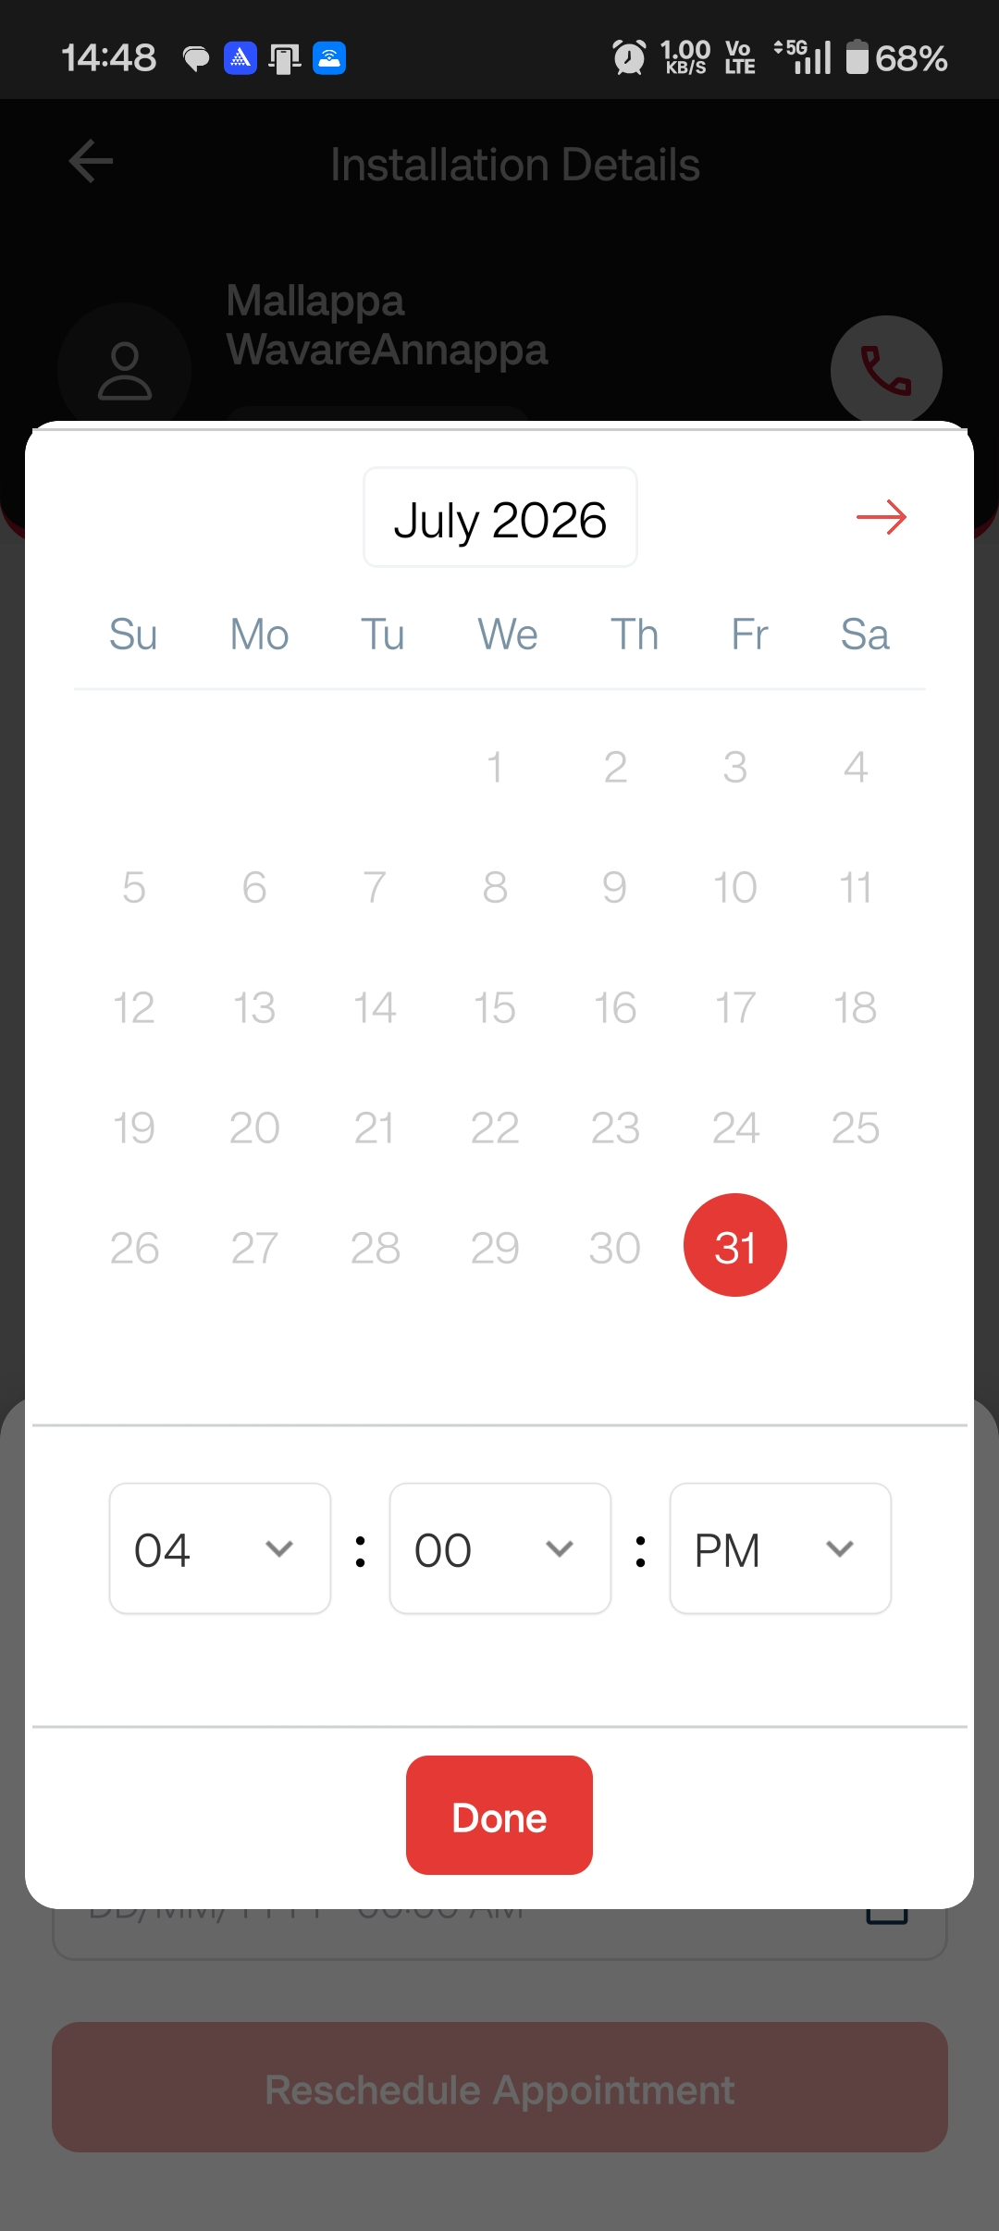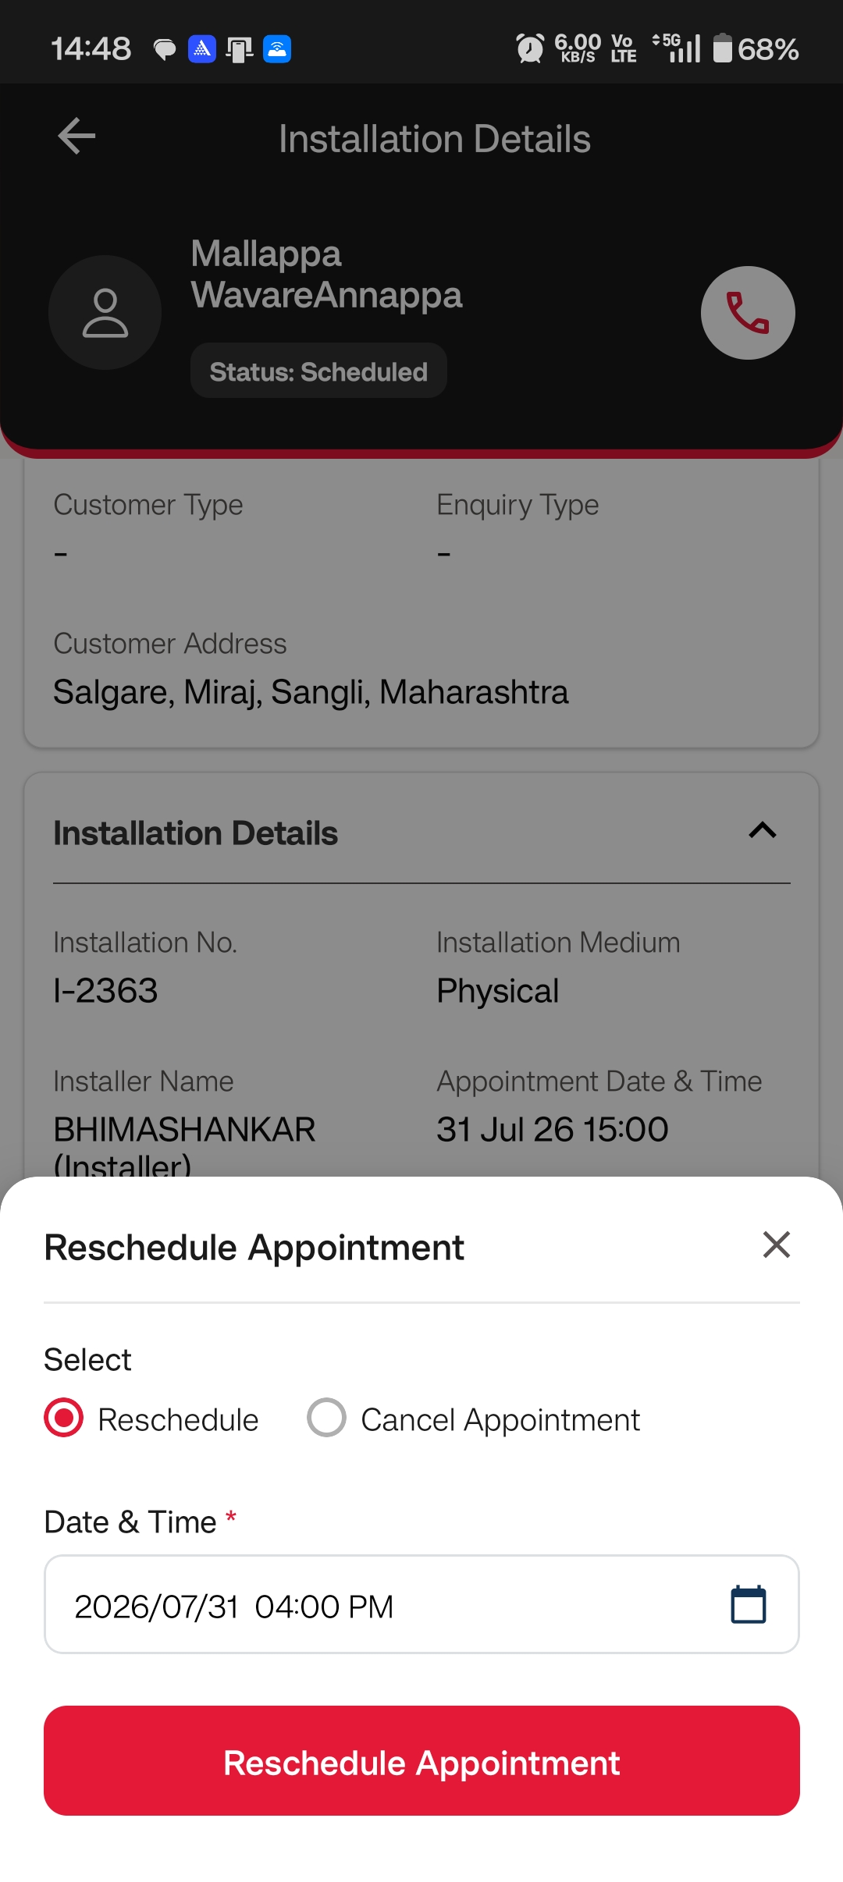
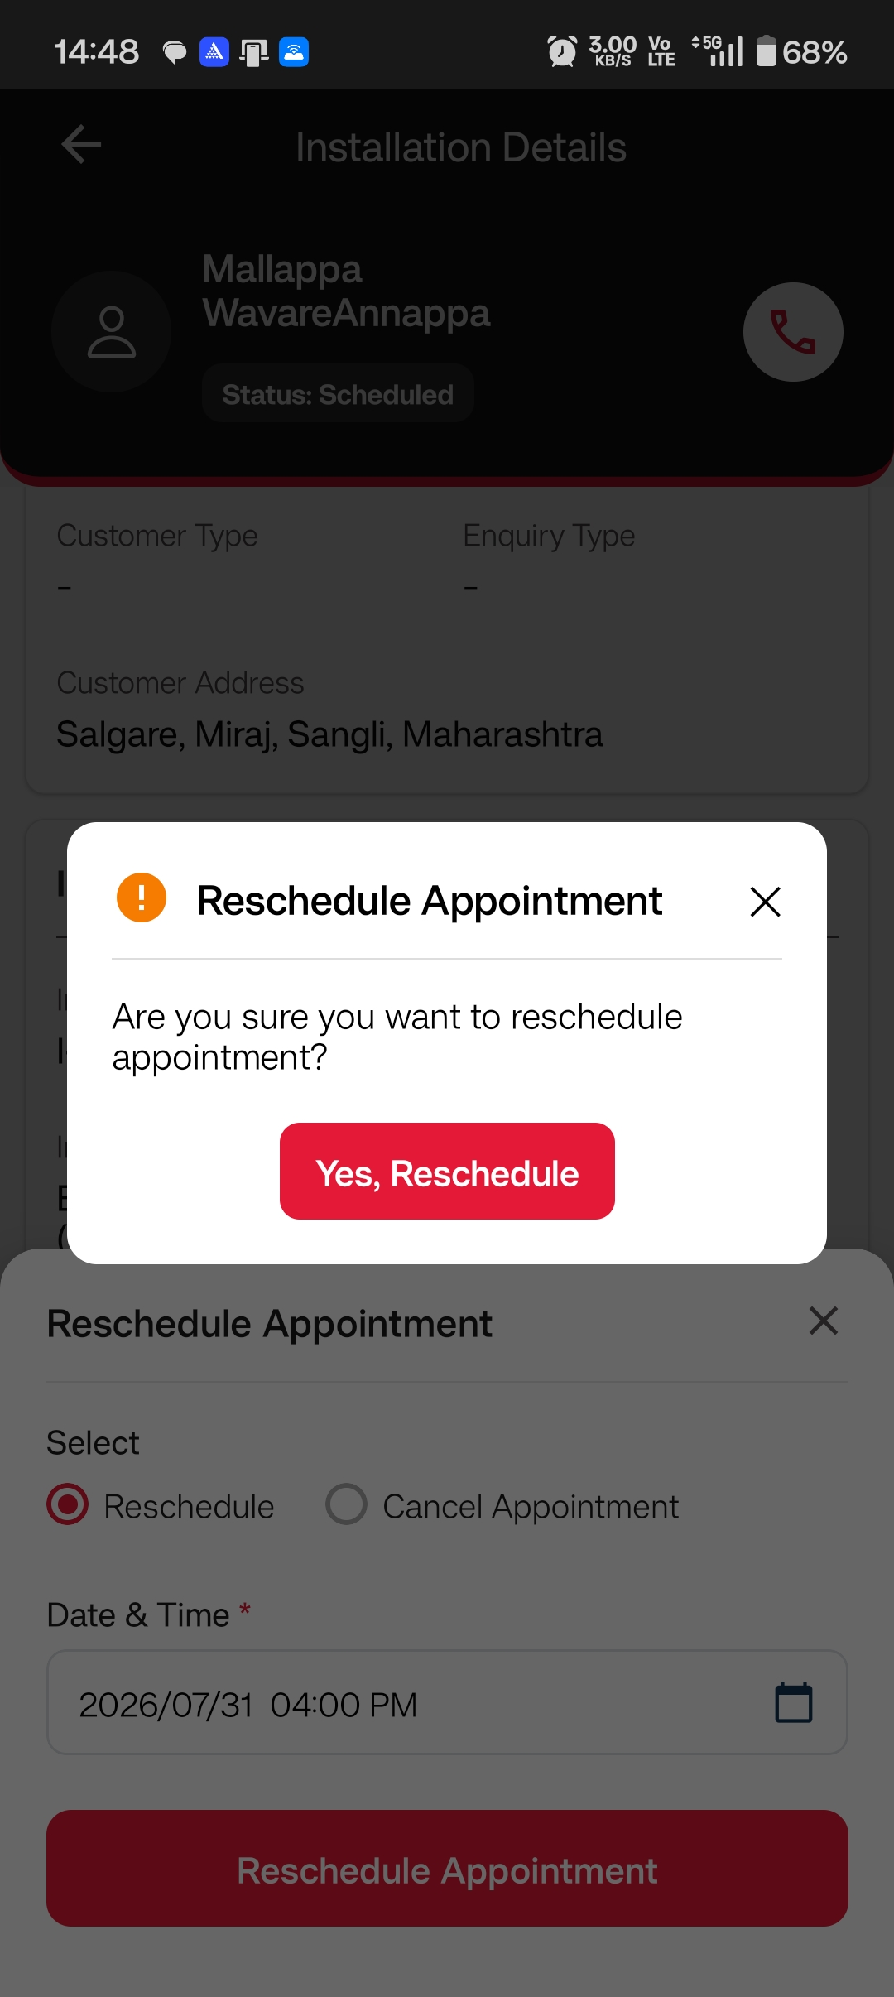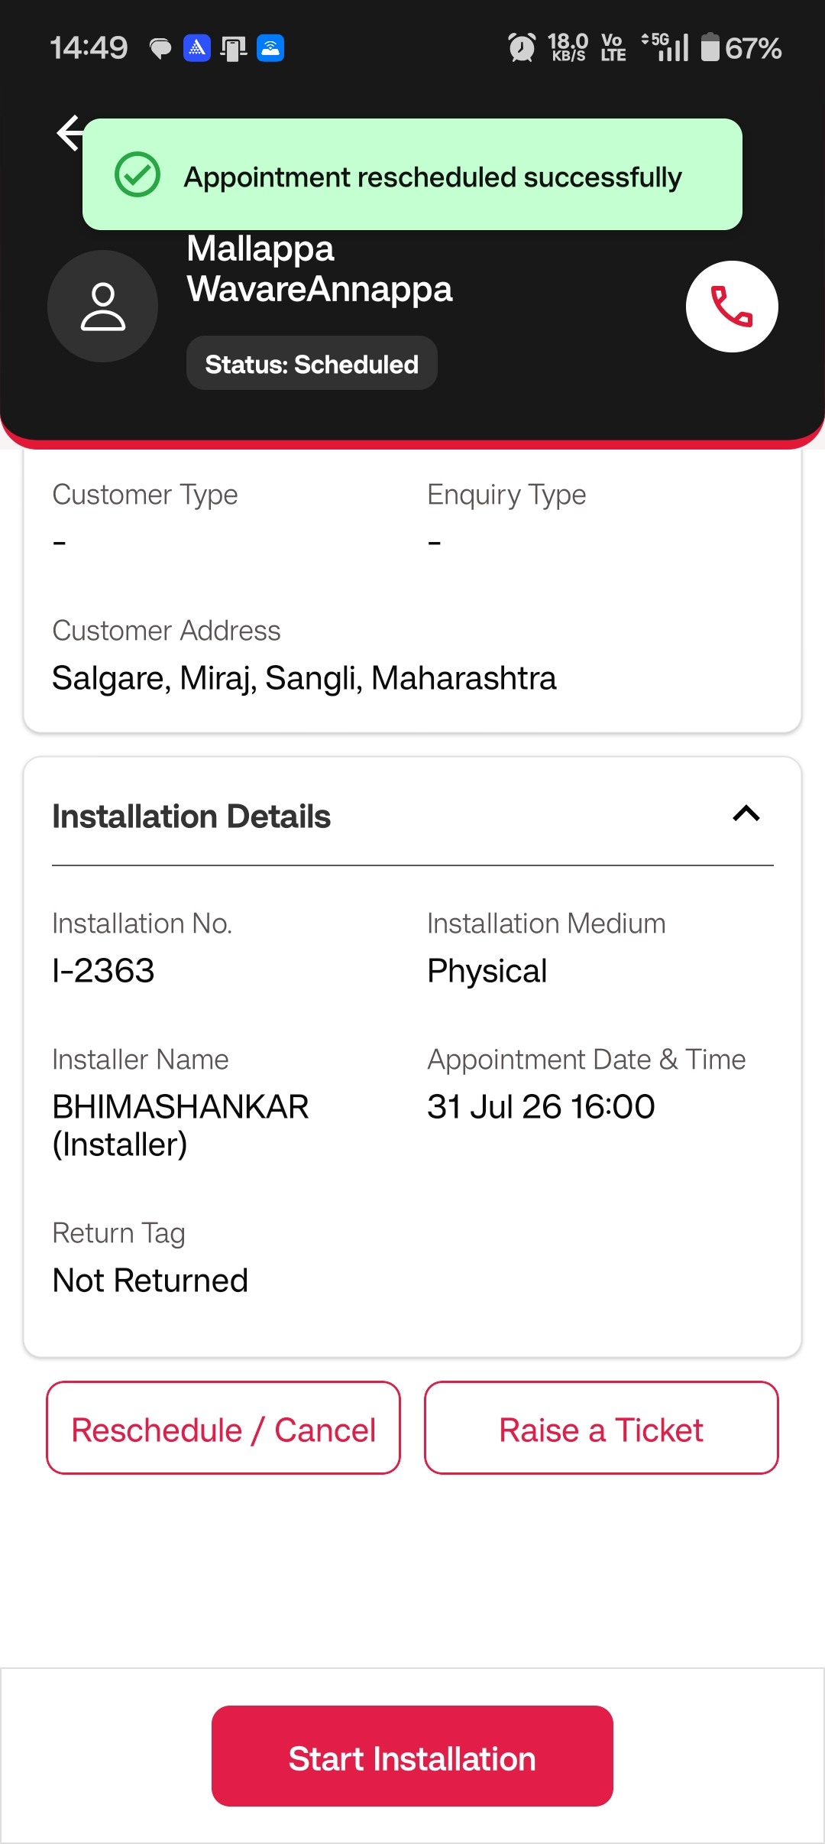
Cancel Appointment: Once Installer clicks on Cancel Button Installer has to select the Cancellation Reason as mandatory field and confirm to cancel the installation
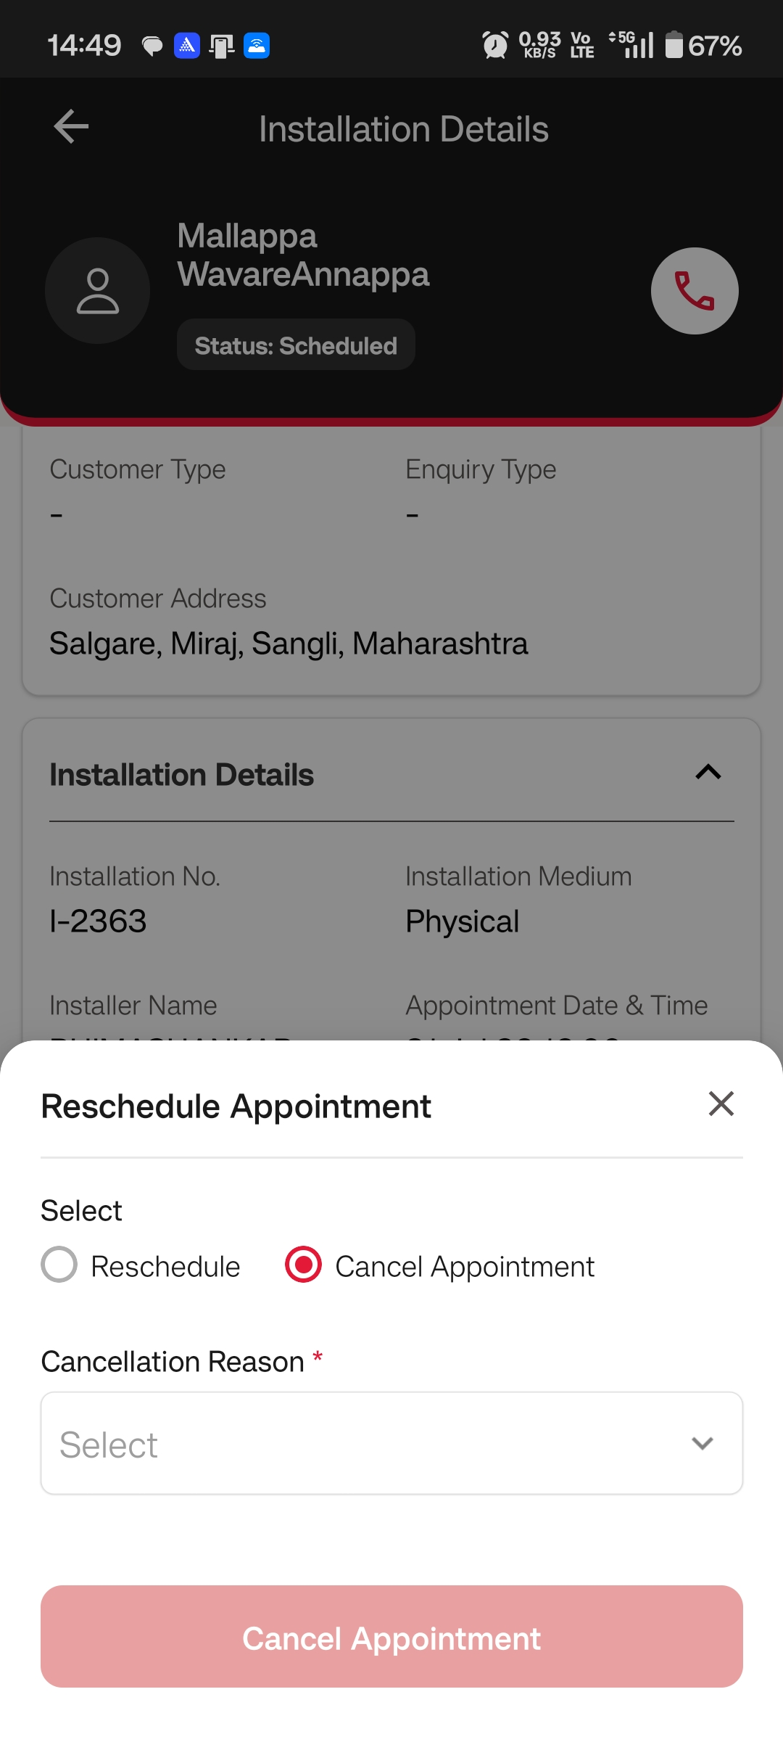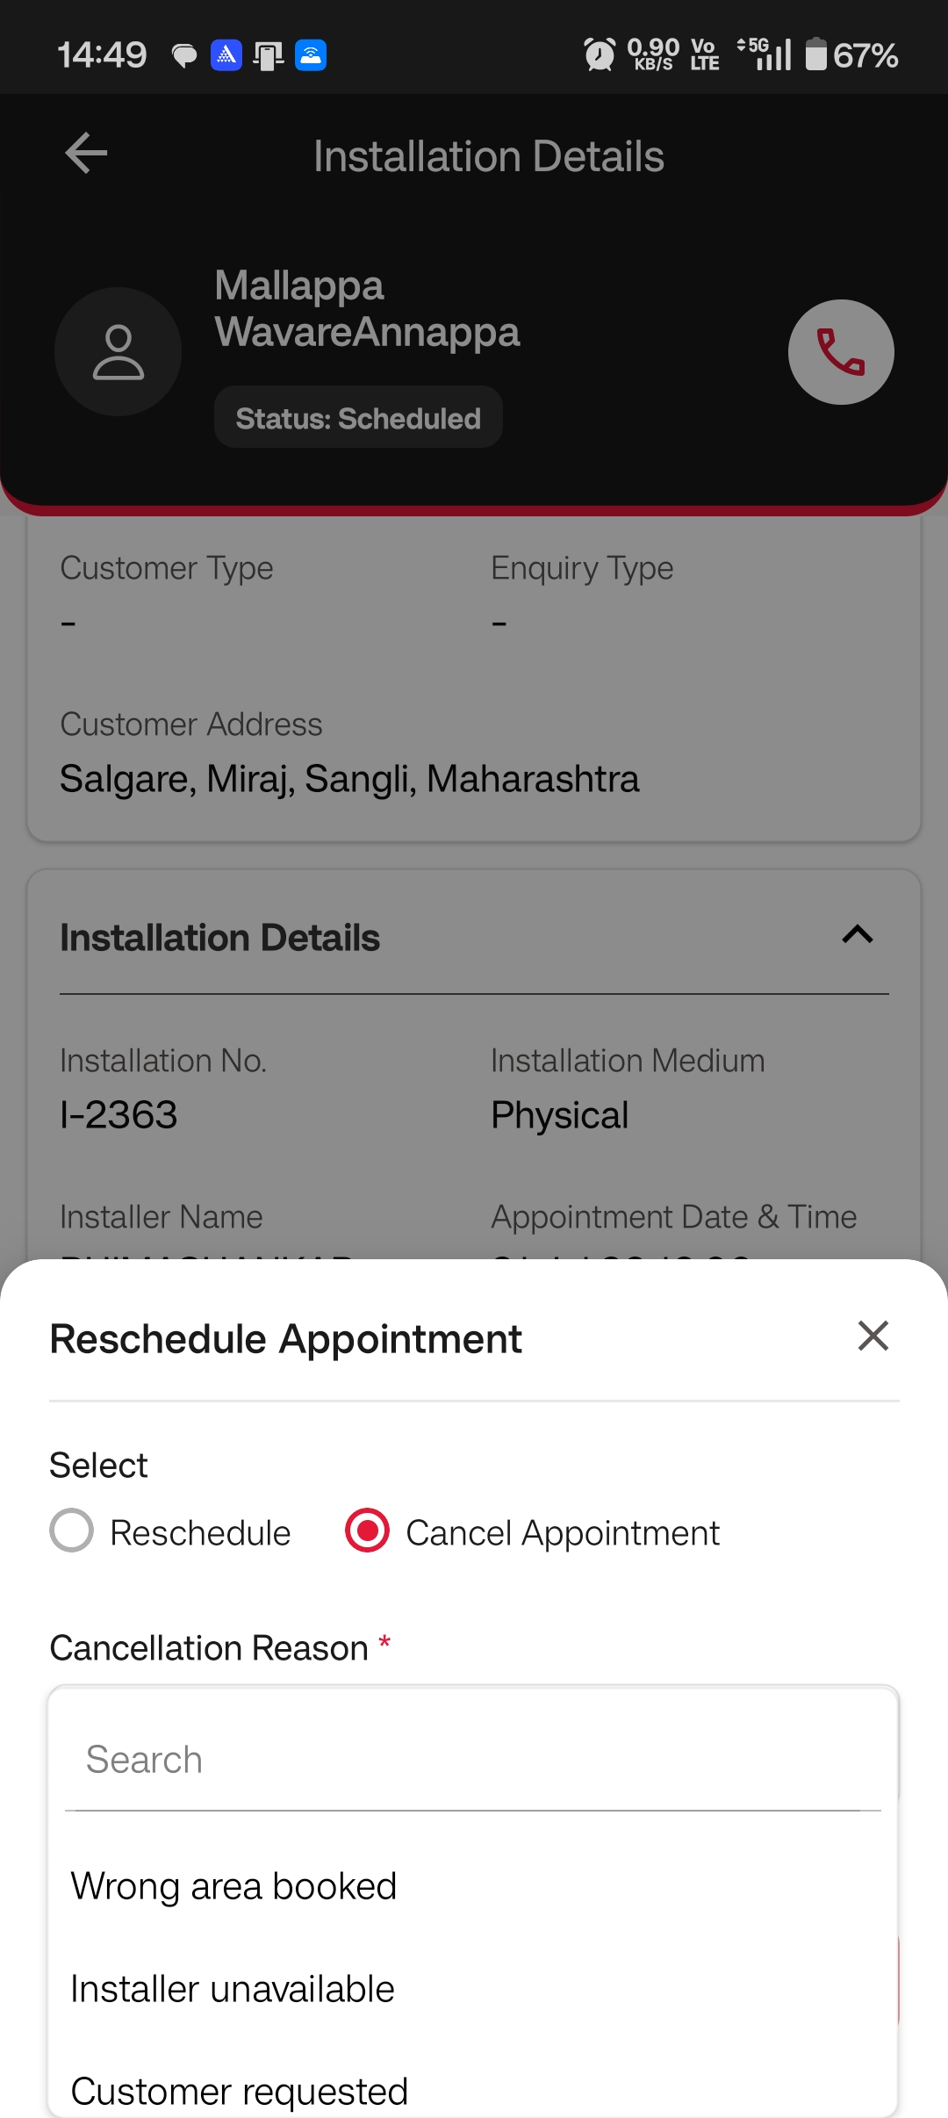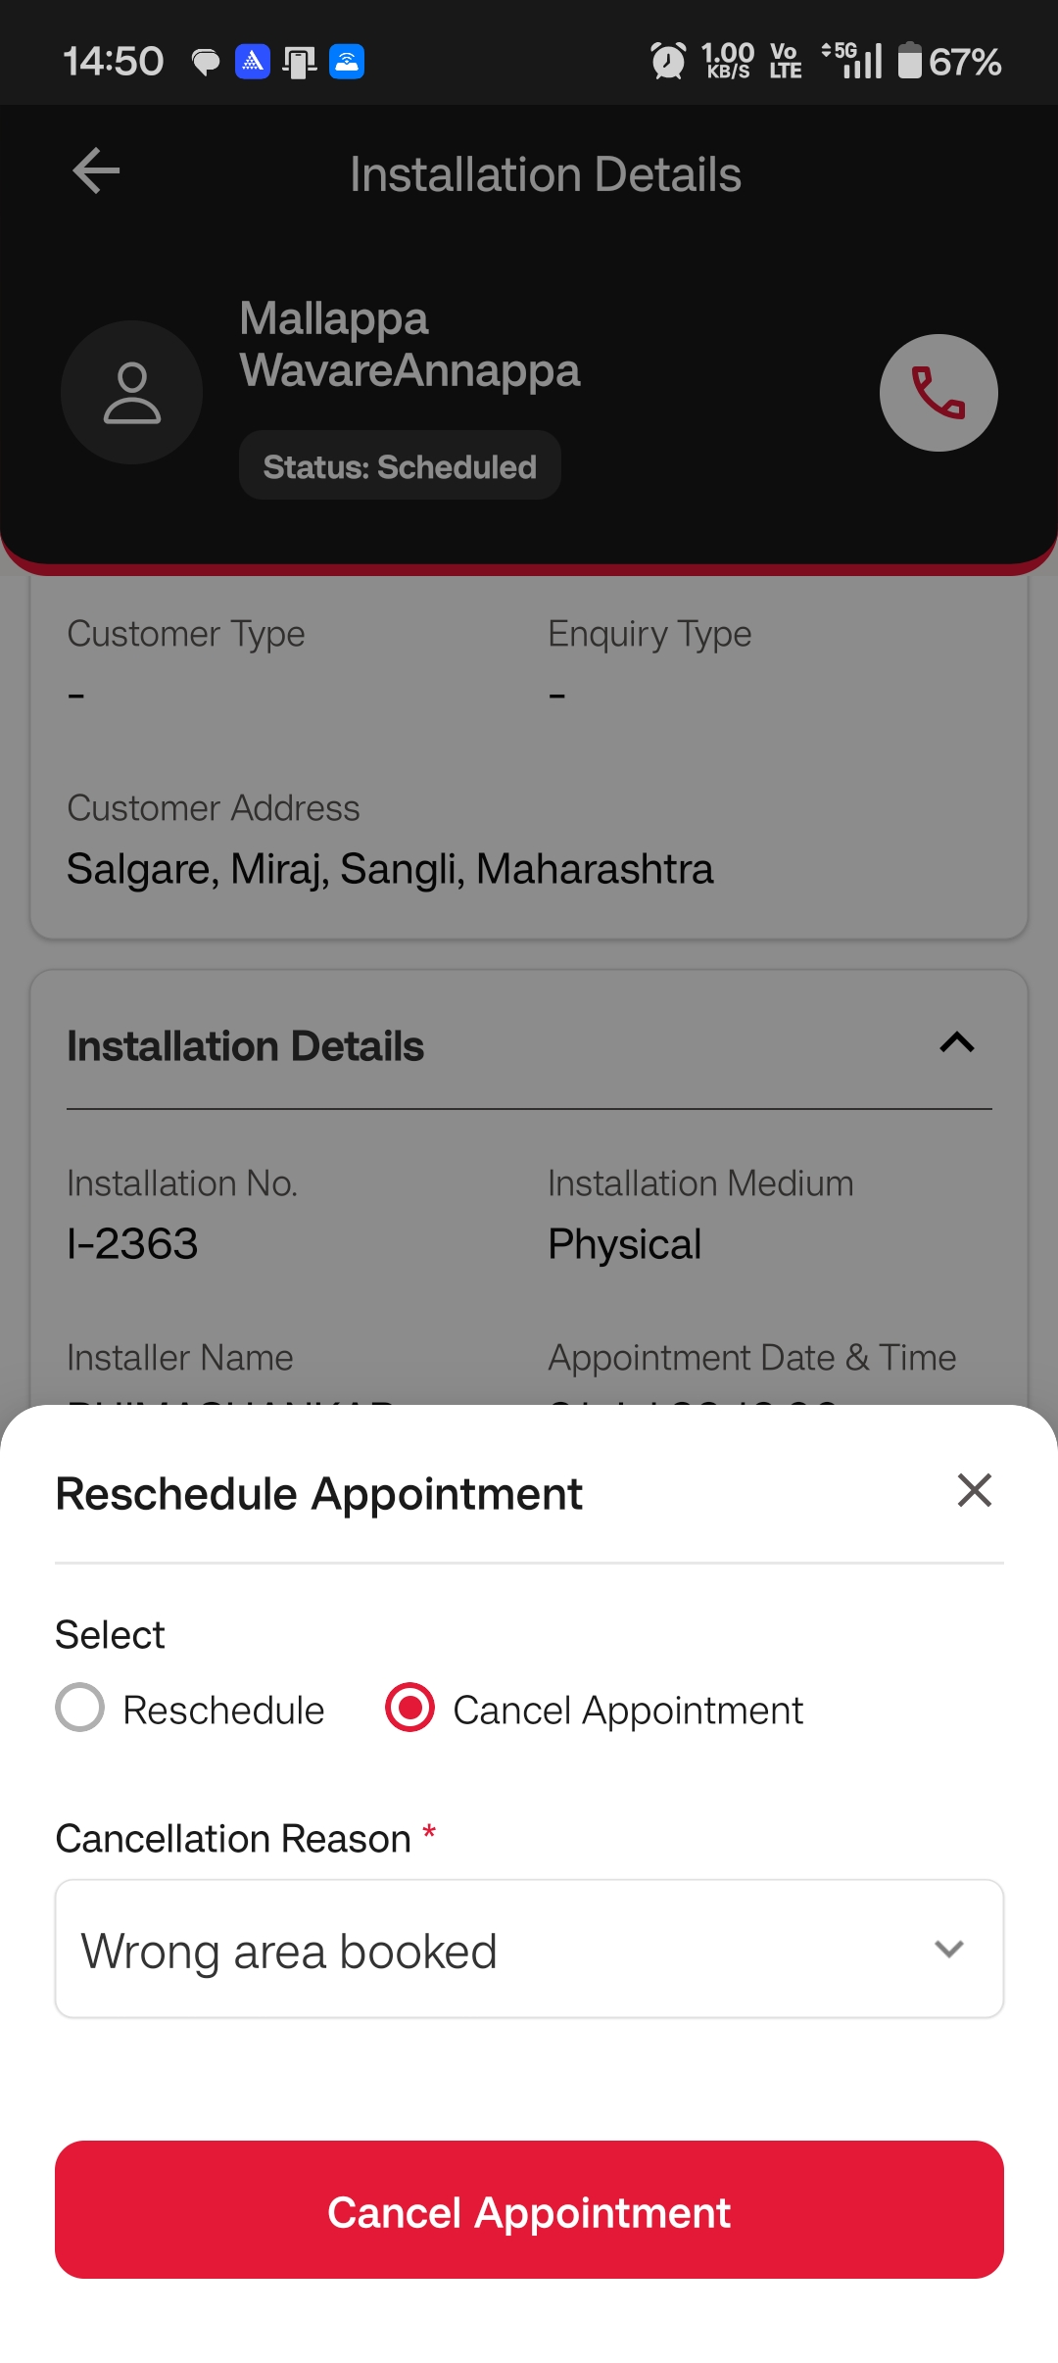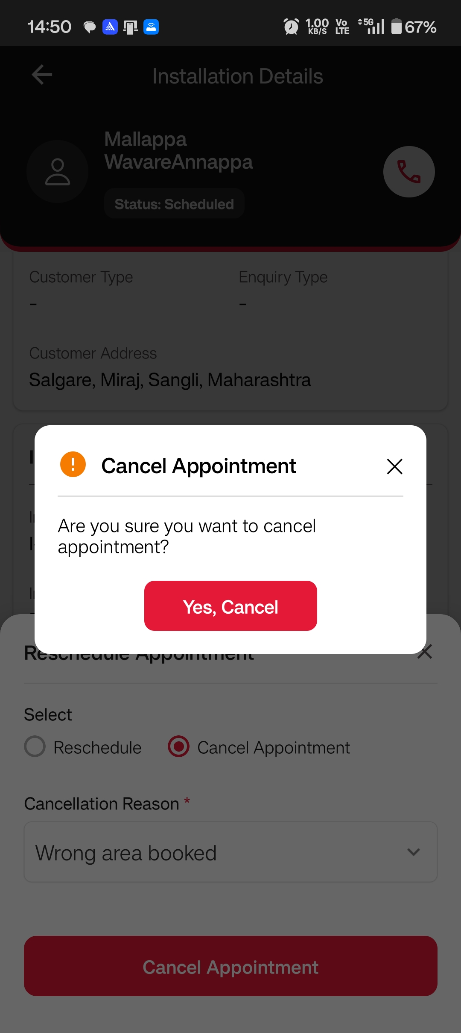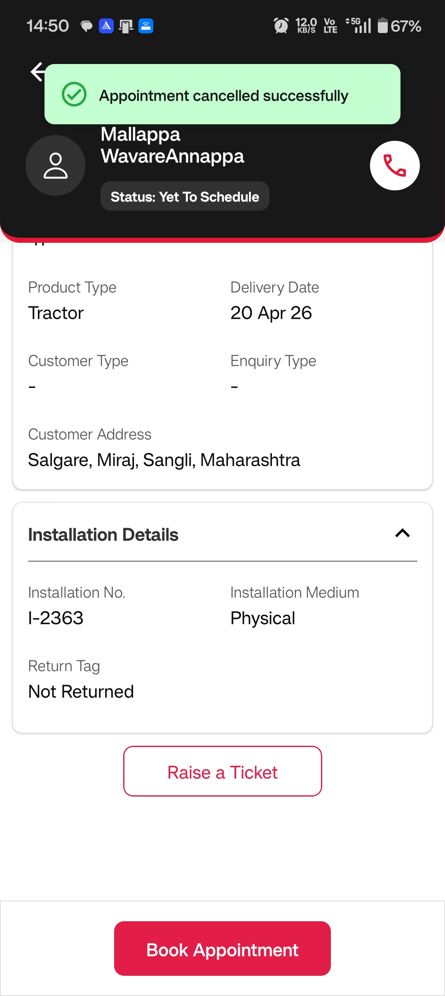
Installation Process:
When Installer Starts the Installation , Installer has to select the medium on which customer wants to receive the OTP
Start OTP and End OTP gets triggered to customer’s mobile number
Enter the valid OTP and click on Verify OTP
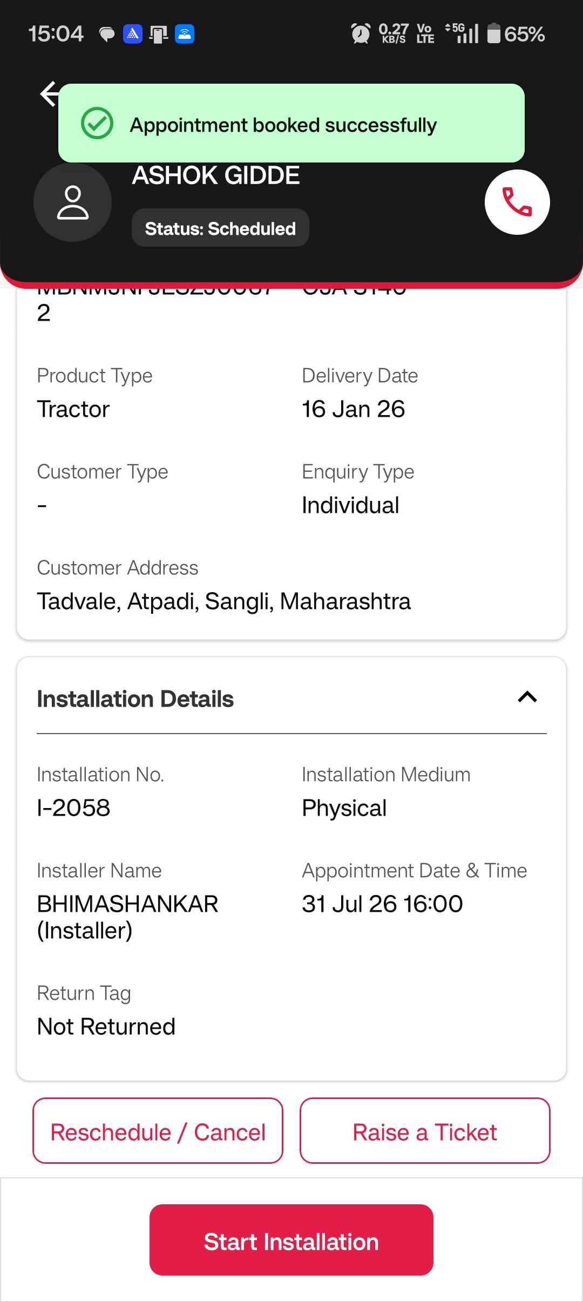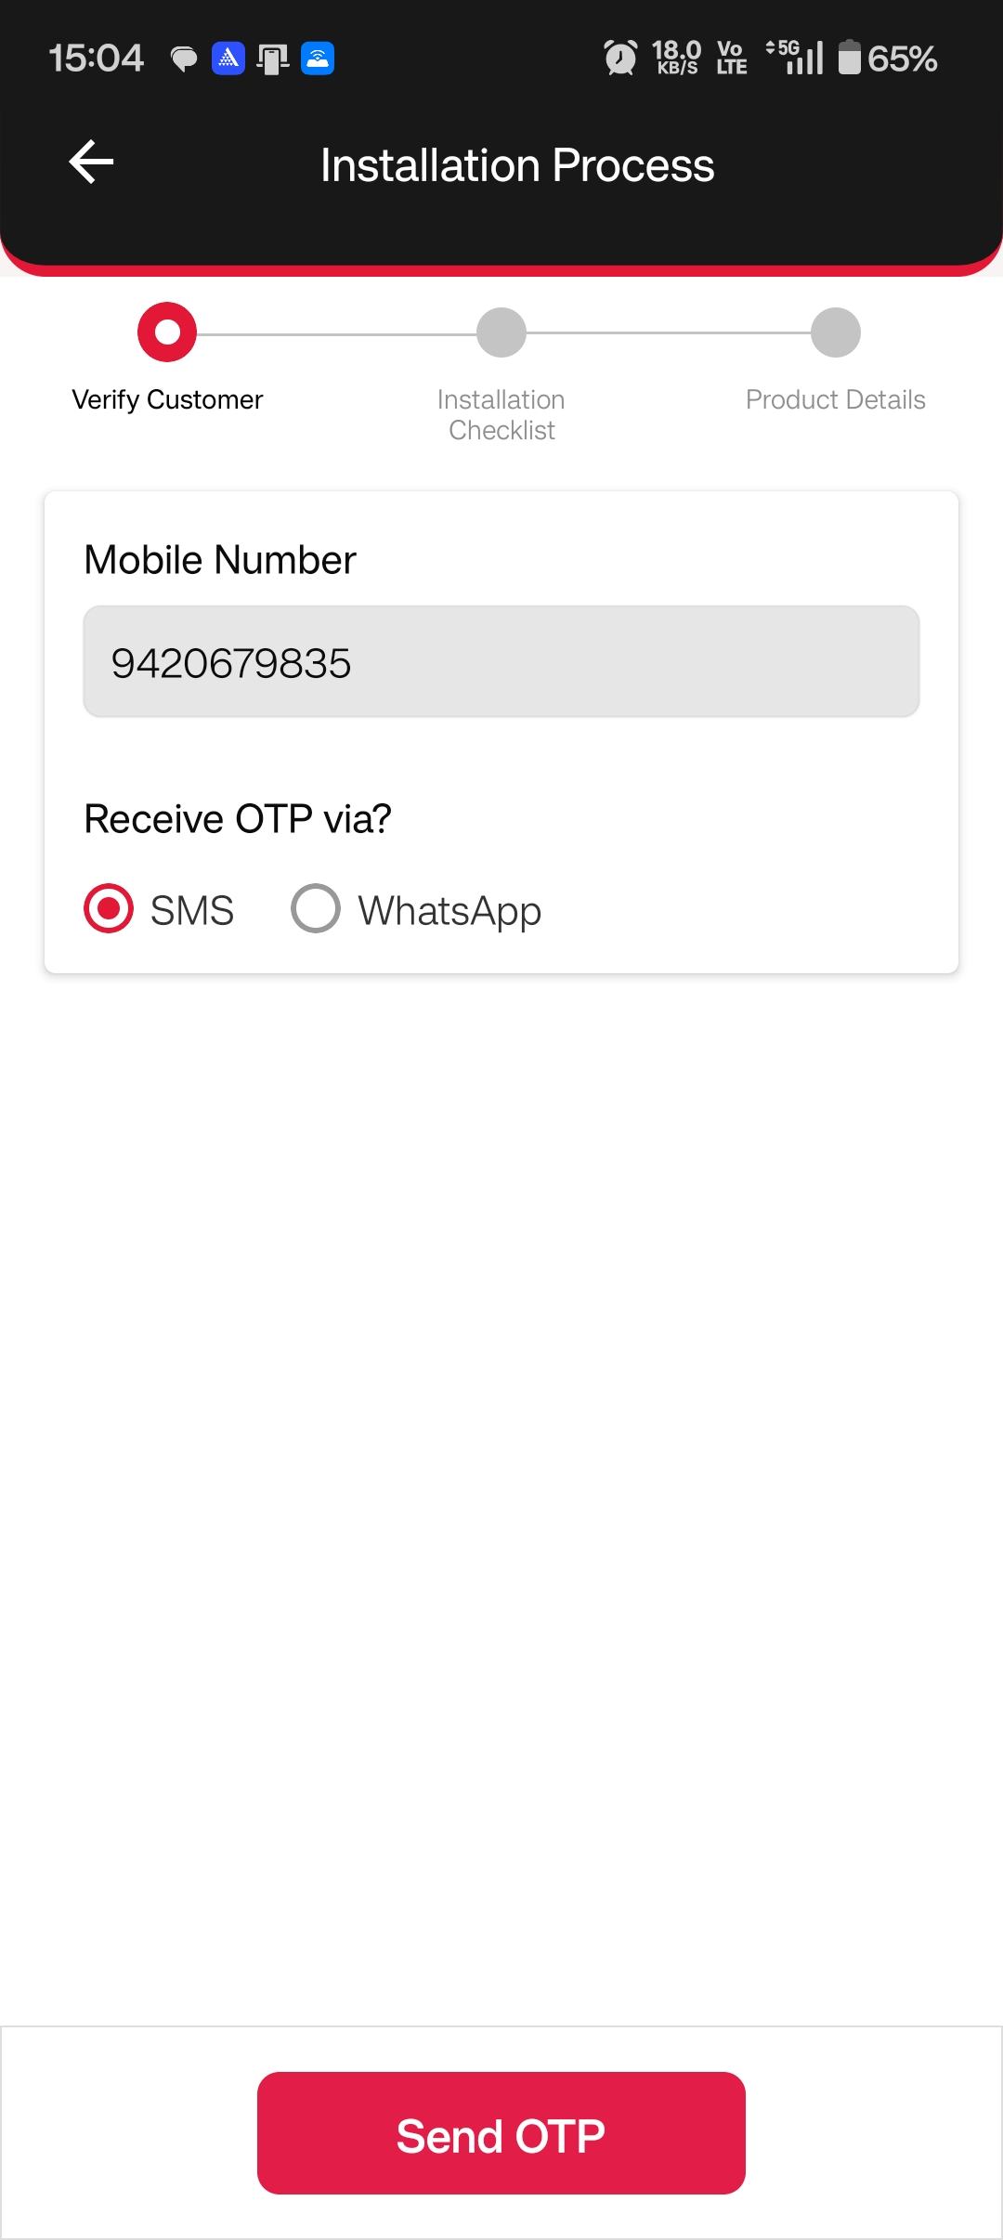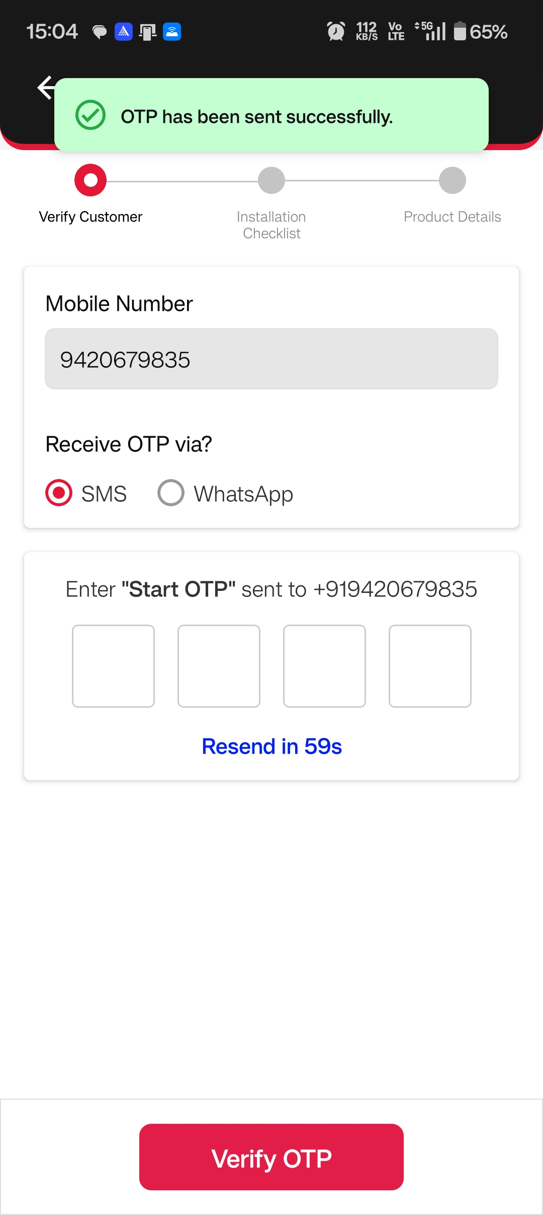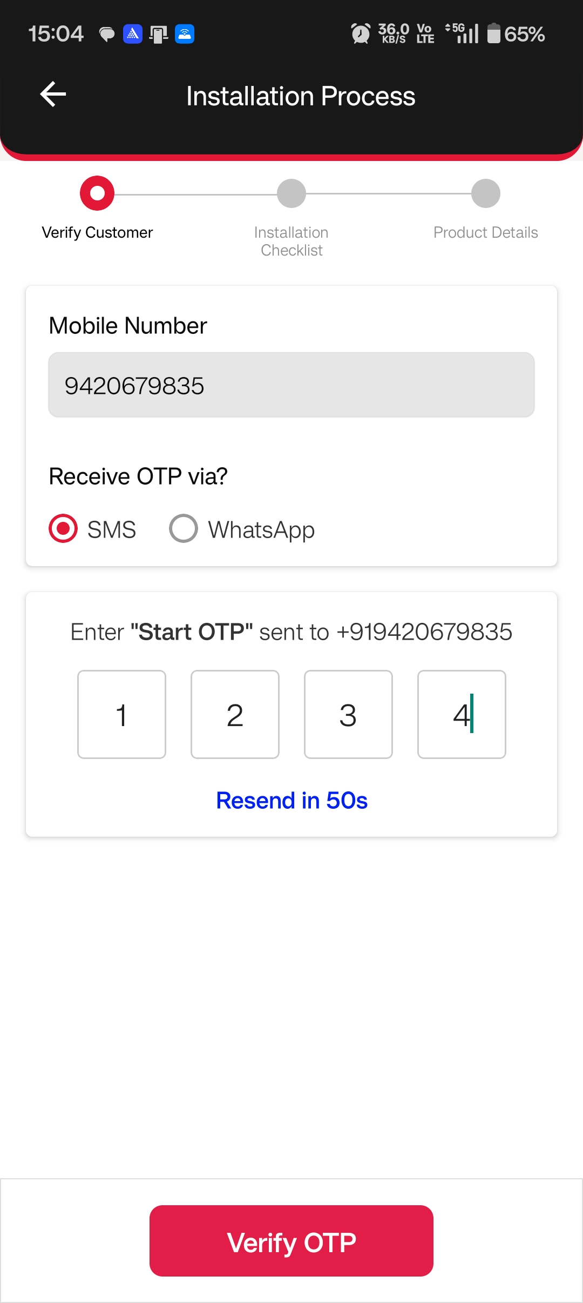
Once OTP is verified Installation Checklist will get displayed where Installer can click and watch the video
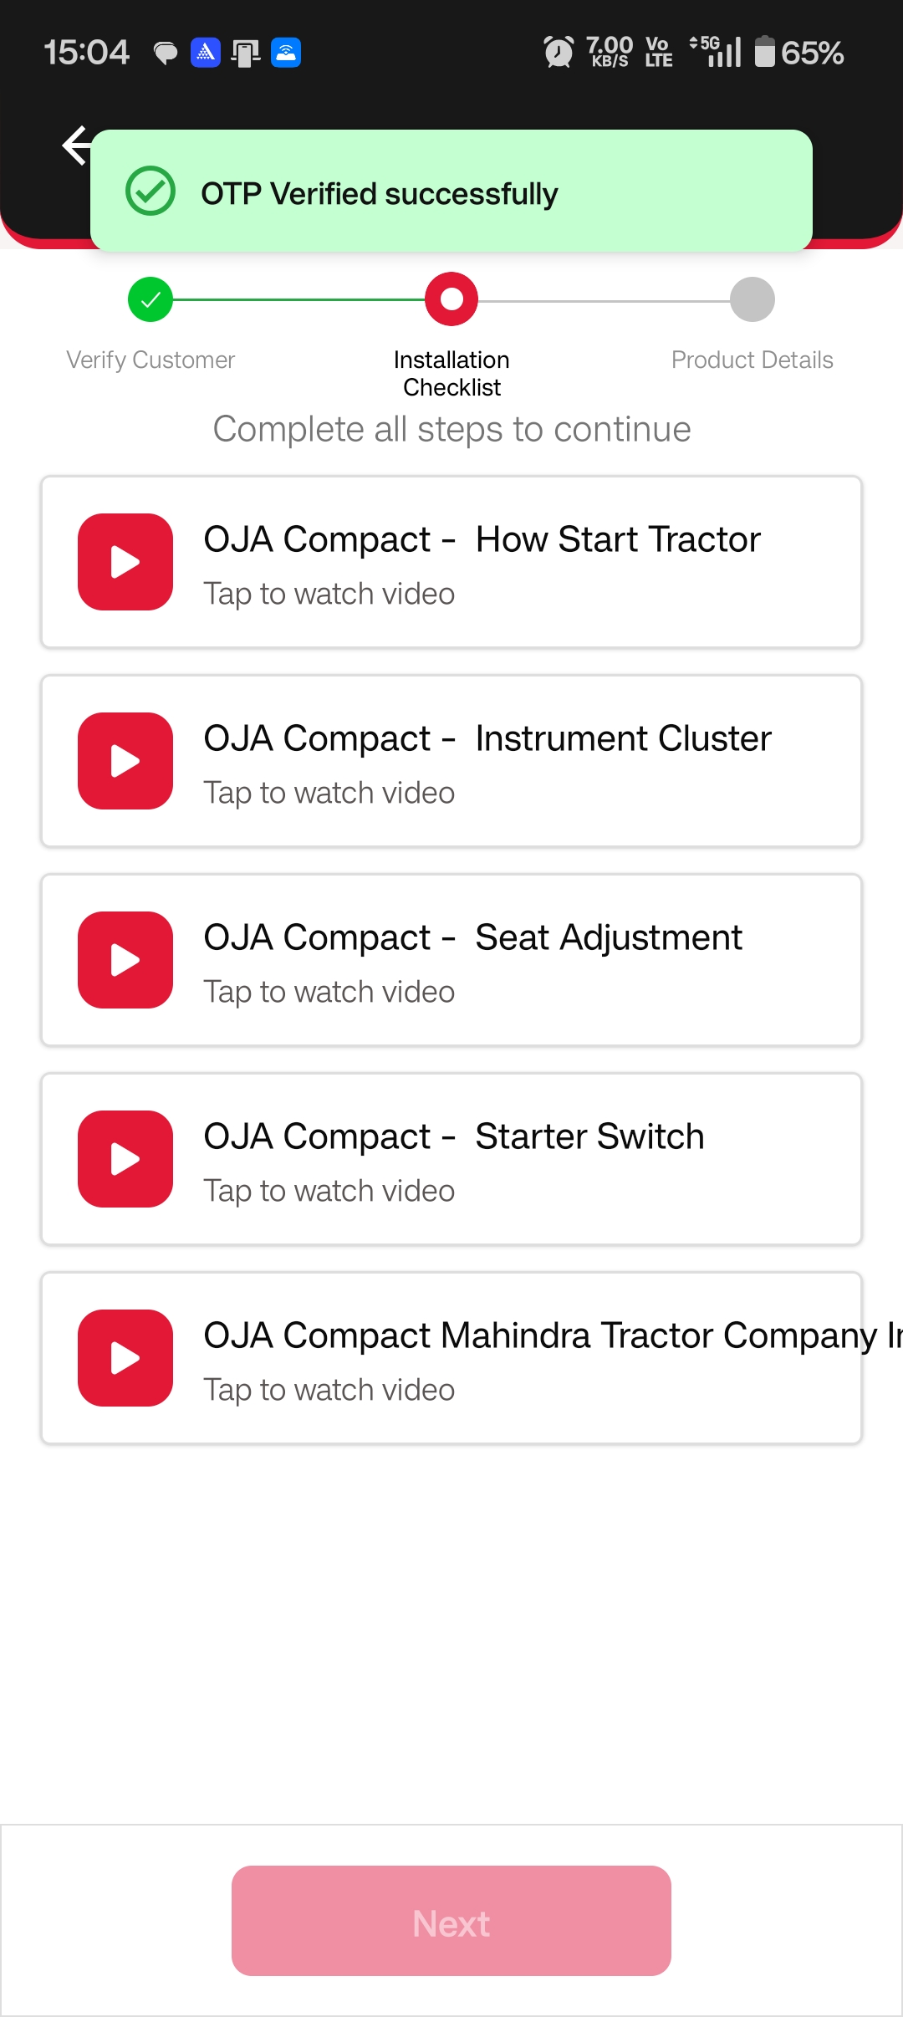

If Installer wants to change Language click on Video Language dropdown to view in Preferred language
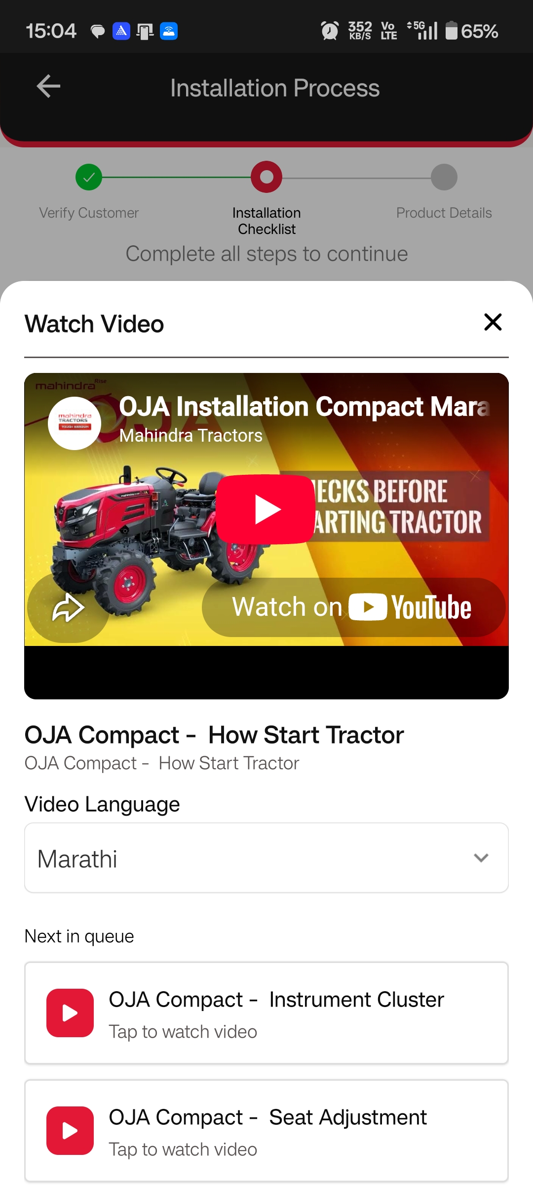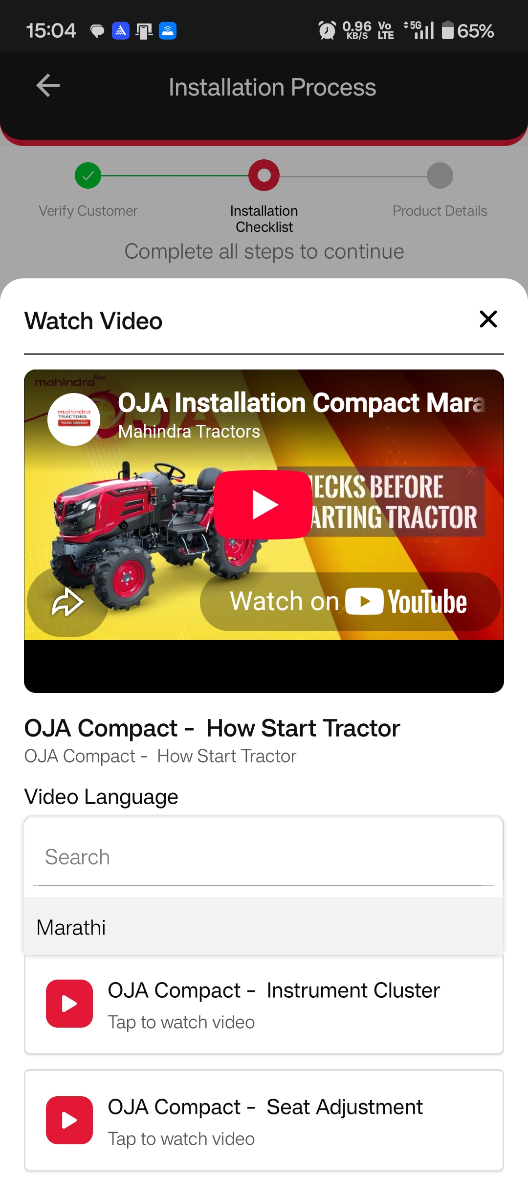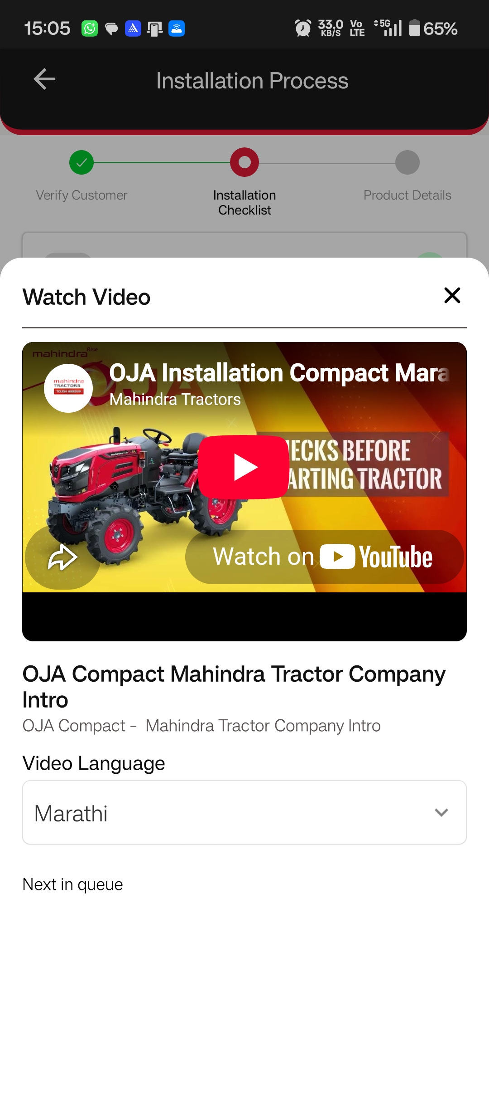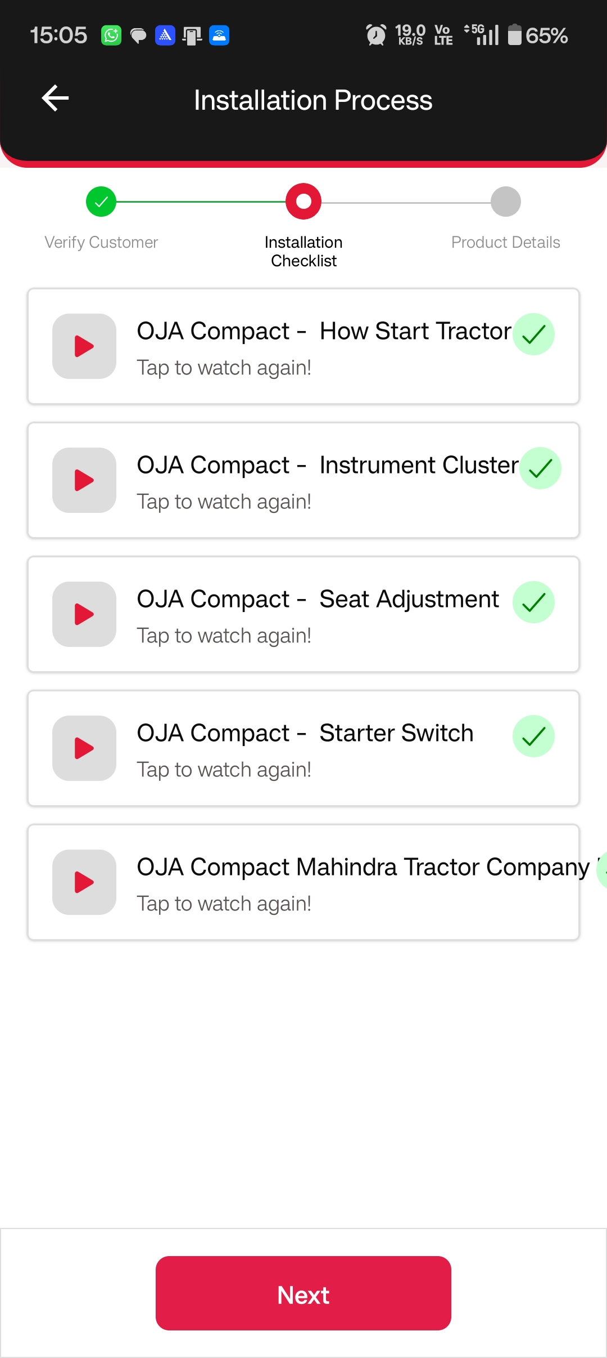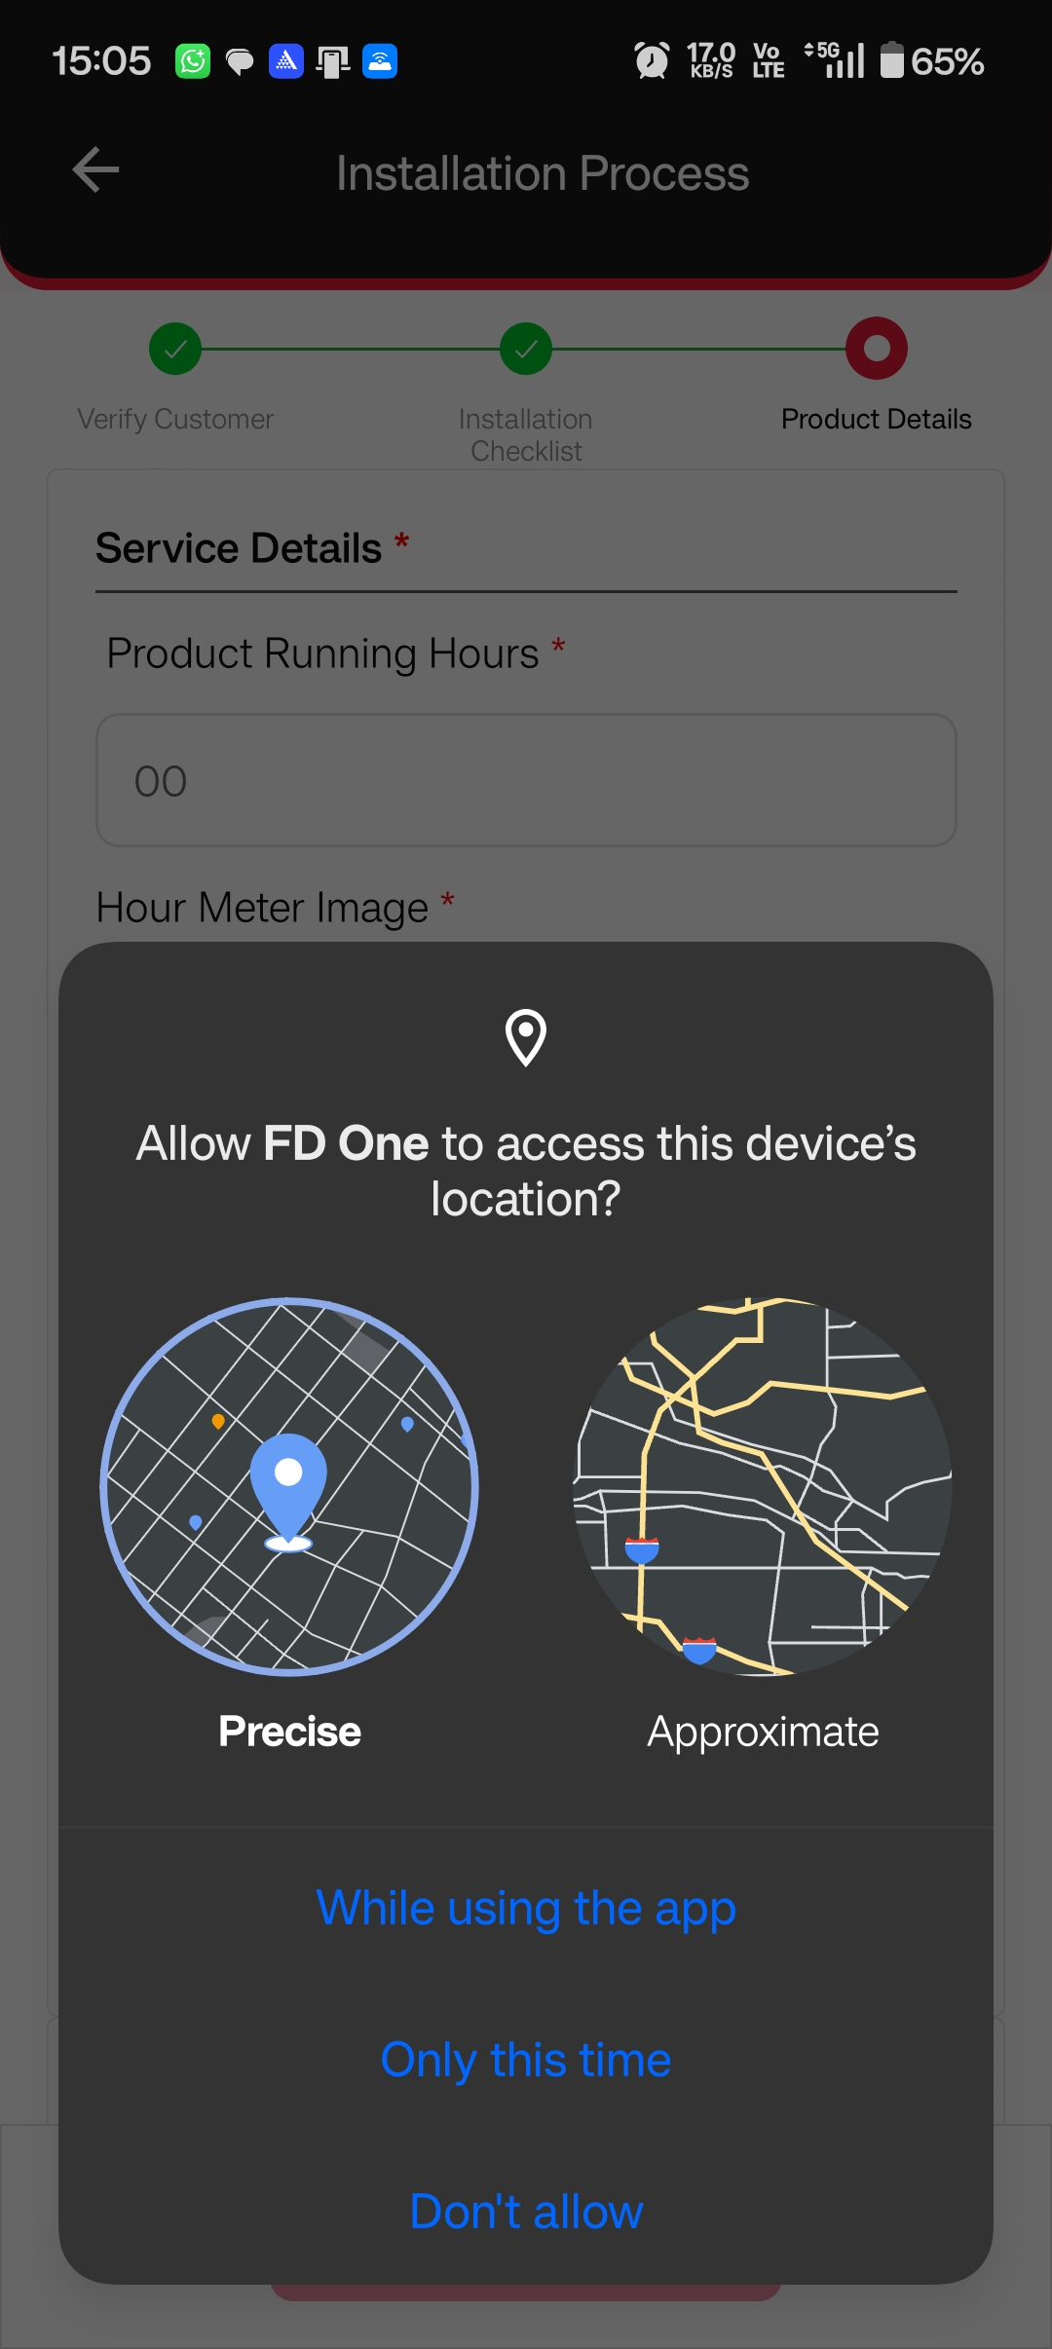
Once Installer completes the checklist videos Installer has to enter the Product Running Hours under Product Details
To Start the Installation, Installer has to capture the Hour Meter Image and Serial number and click on submit (Location of the device must be ON in order to capture the images)

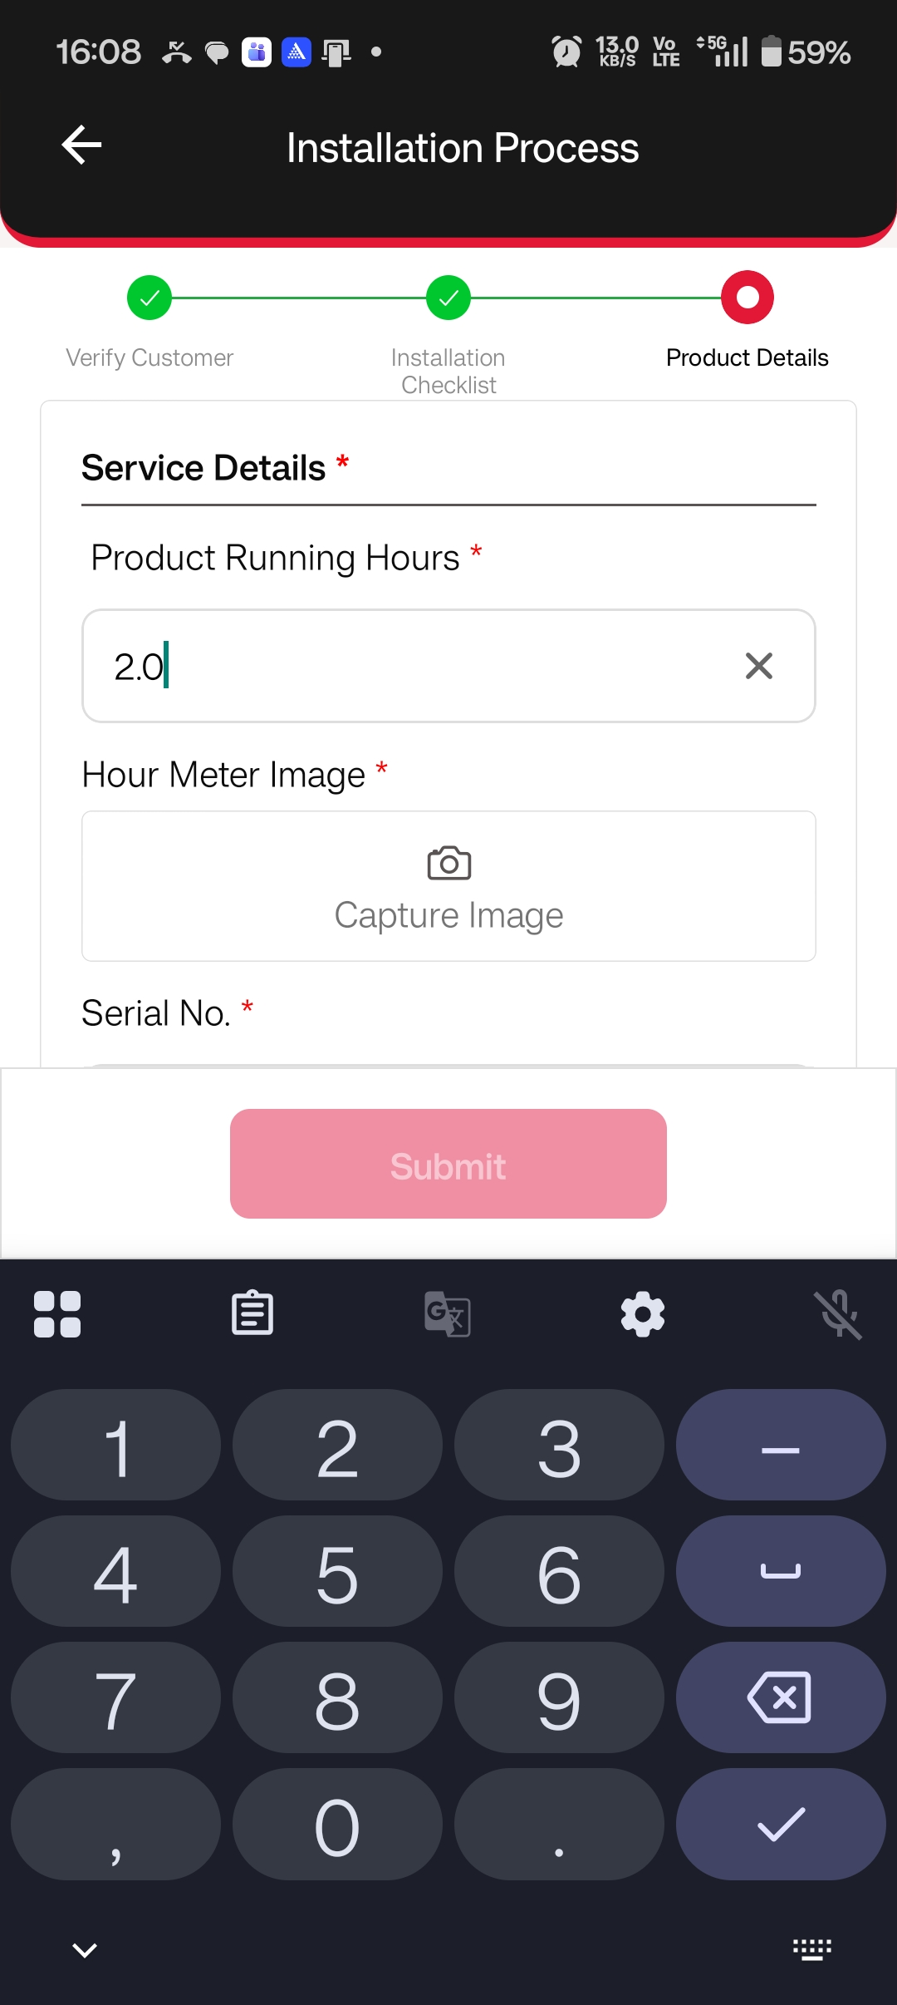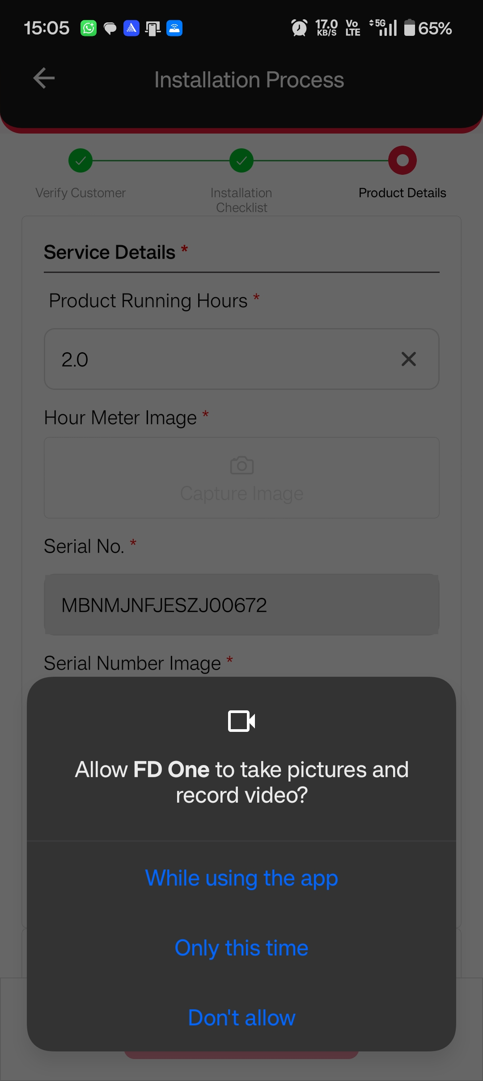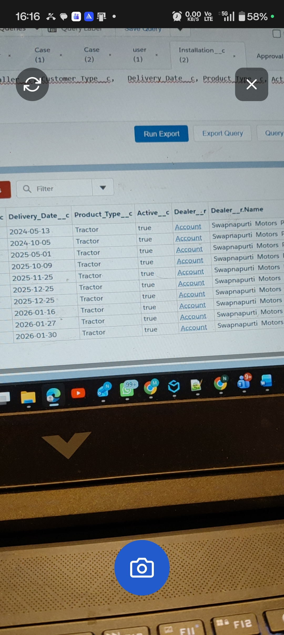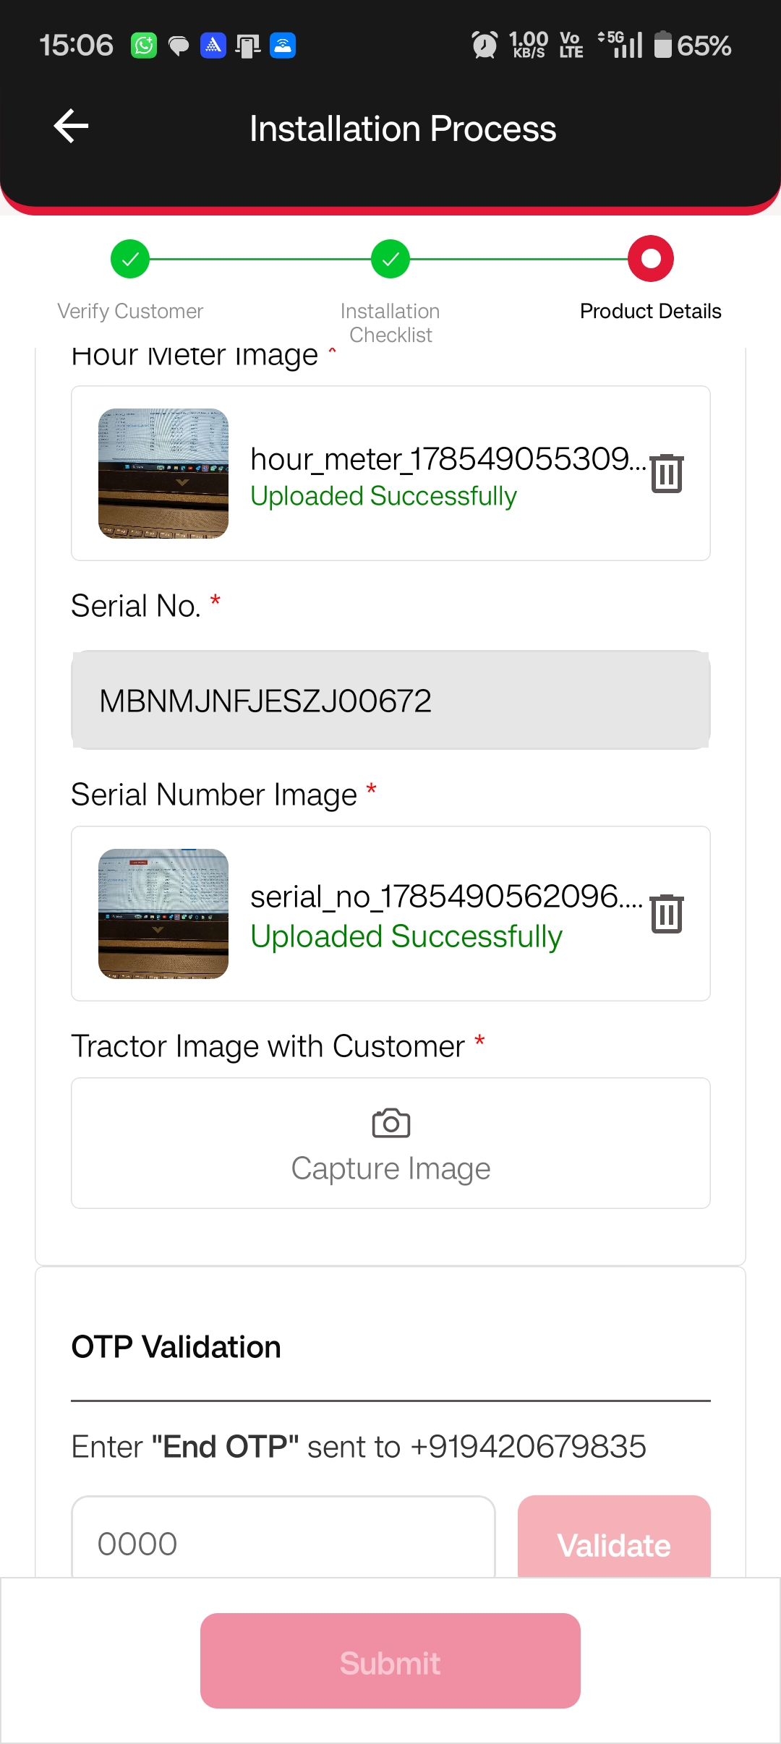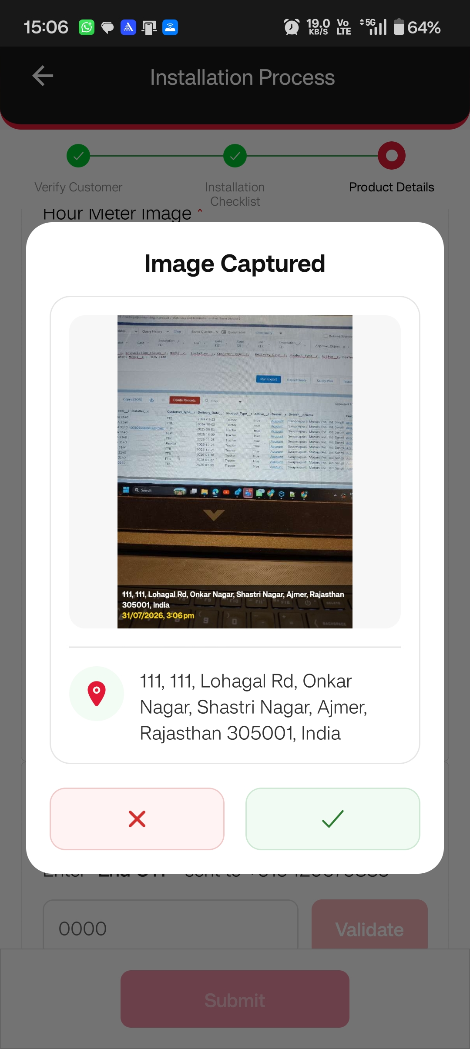

Enter the End OTP to End the Installation
If the End OTP is expired or not valid click on Resend End OTP which is in blue color
Once the OTP is entered click on submit button to end the Installation,.

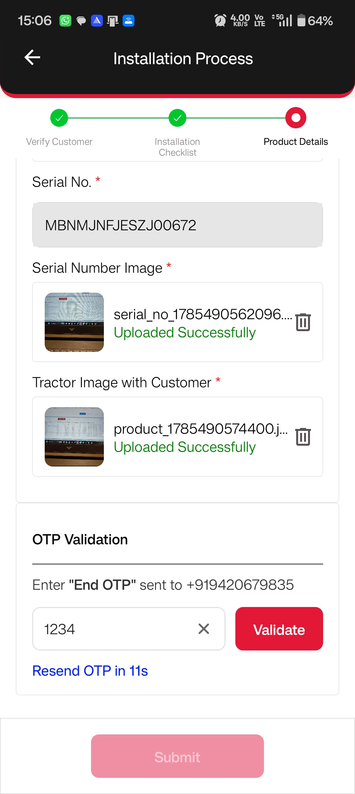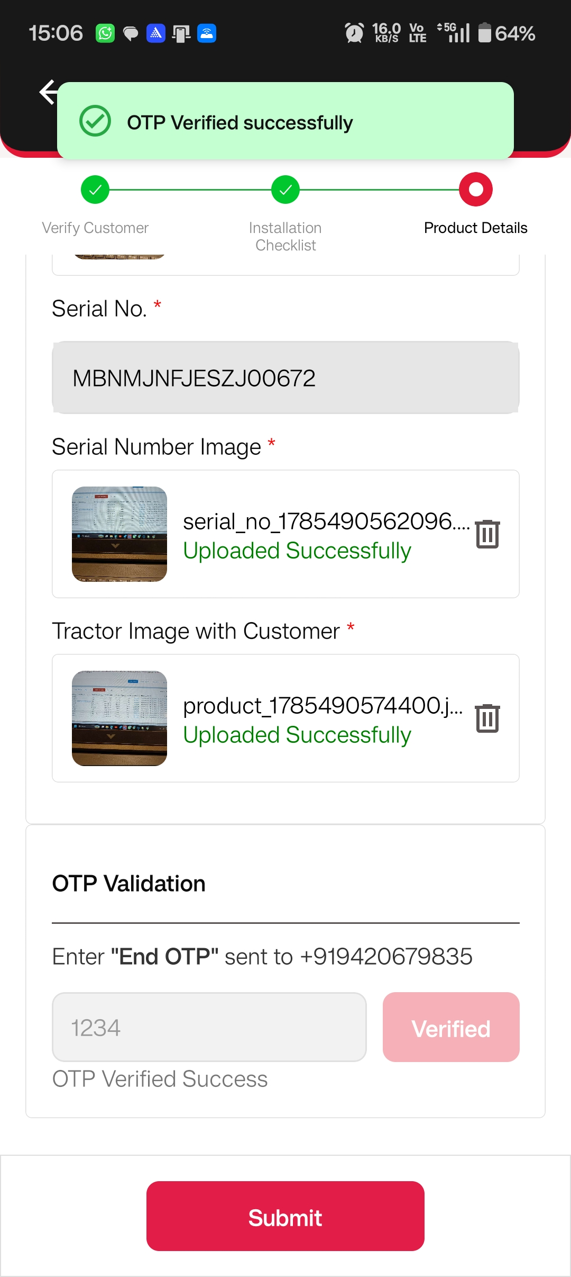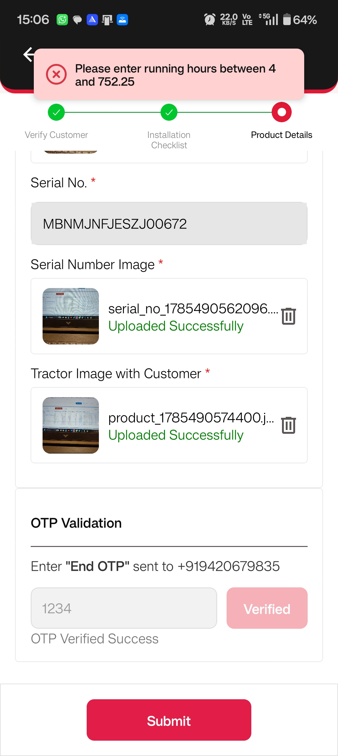

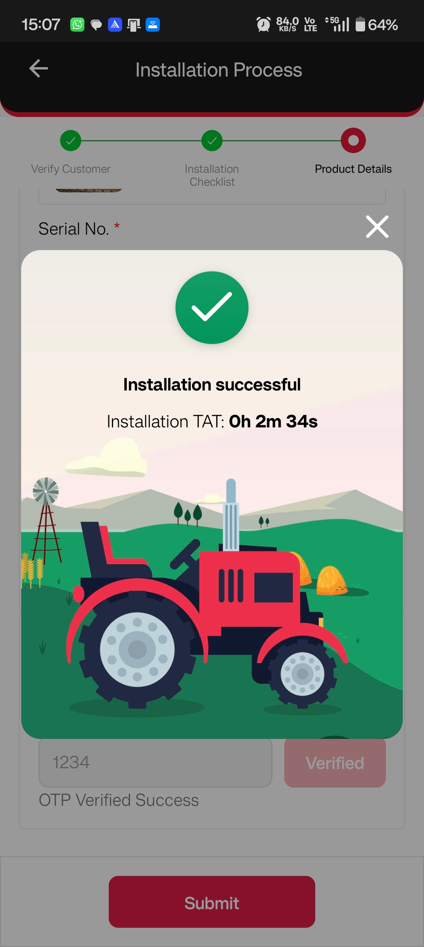

Once Installation is done the Record will be visible under Done Installation Section
