Standard Operating Procedure (SOP)
Counter Sales Invoice Process

Claim Creation
1. Login to Salesforce using credentials.
2. Click on the Counter Sales
3. The page displays the Claim List which were already generated

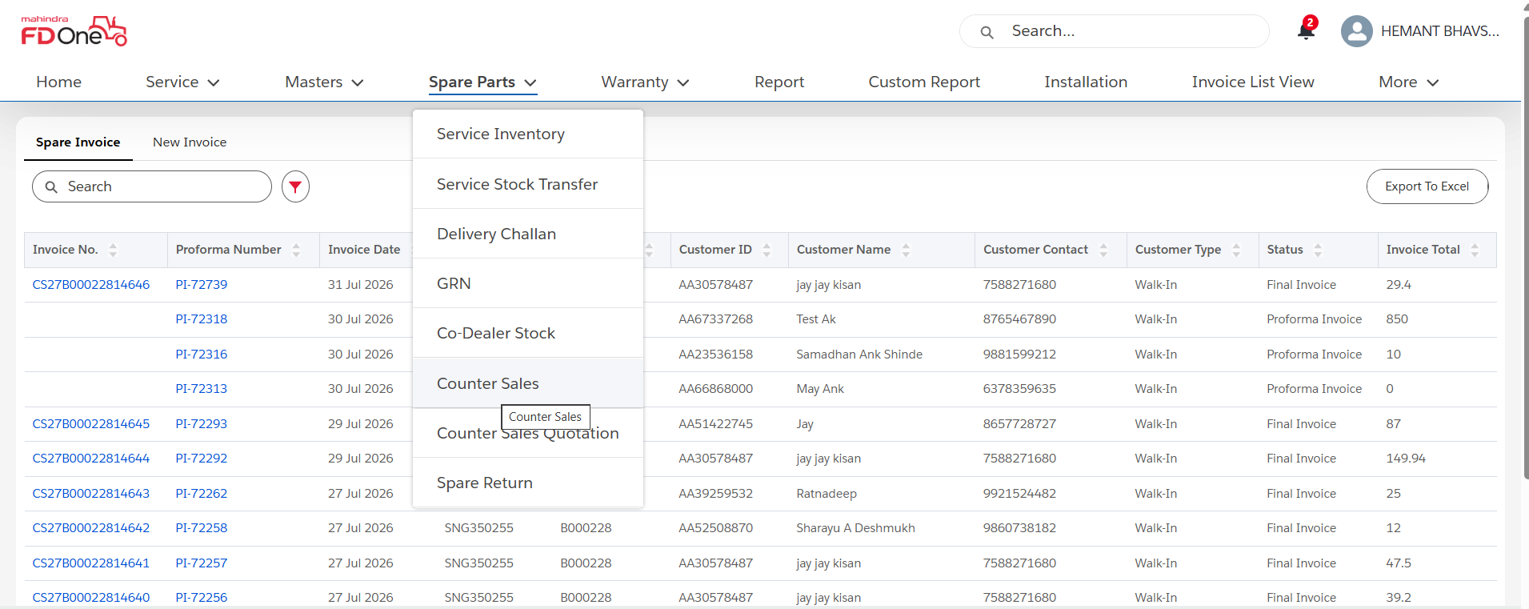
- Click on New Invoice to create a new counter sales Invoice
- User can select under which counter source Invoice needs to be created
- Available Counter Source Options are Walk-in , Retailer, Co-Dealer, Tech Master, Local Mechanics.
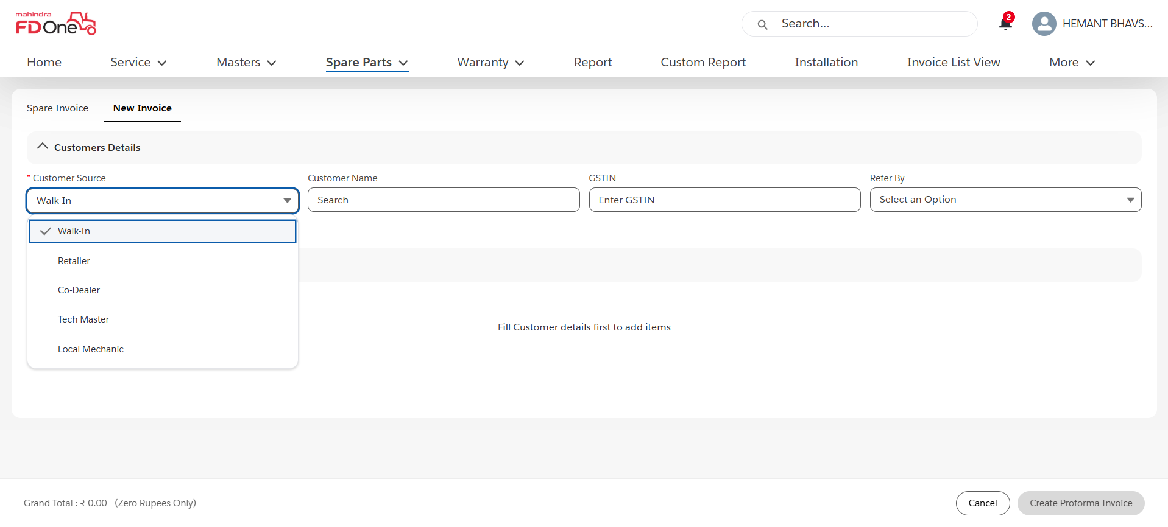

Once Counter Source is selected Select the Customer Name field by searching with proper Mobile Number, Customer Name , Village

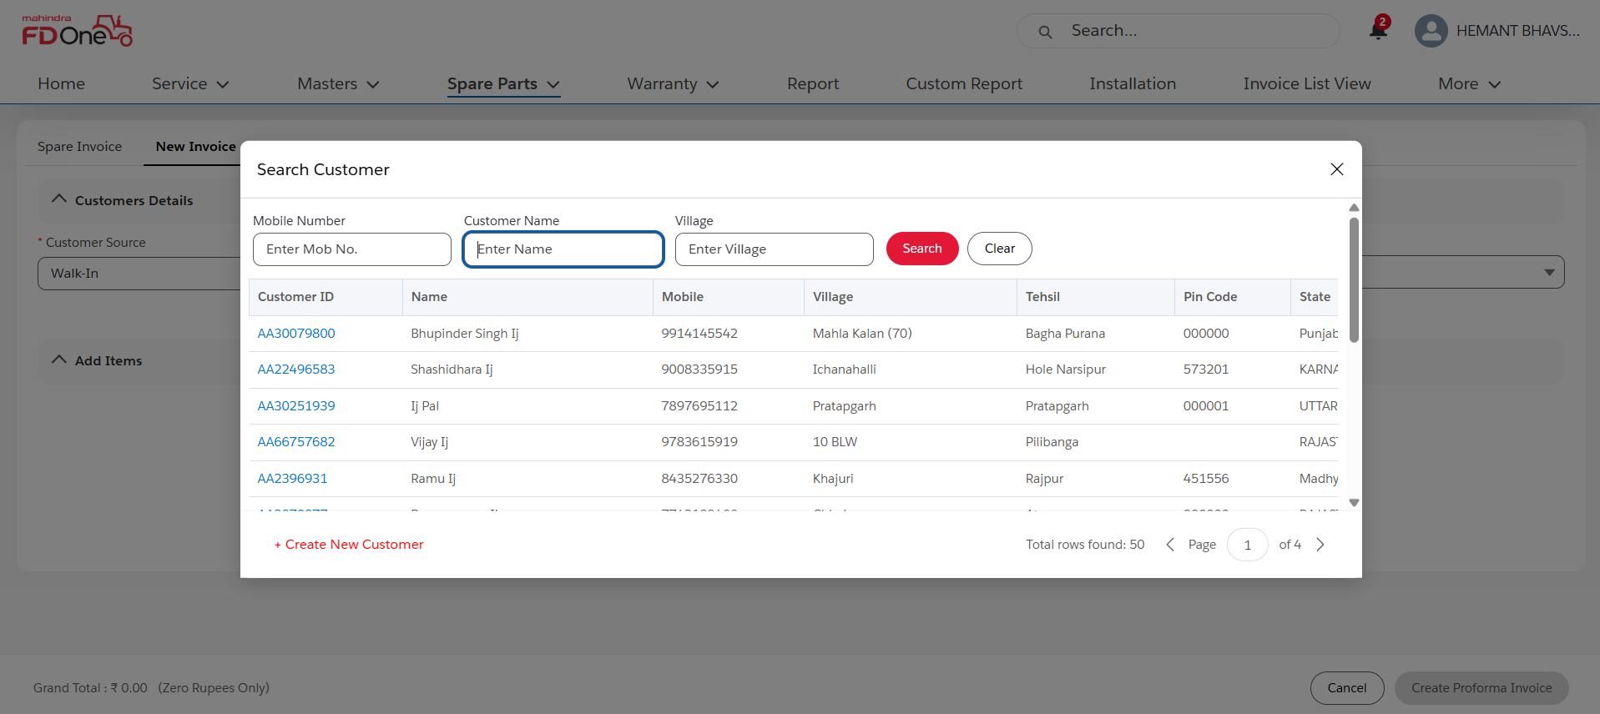

- Once Customer Details are selected if GSTIN is applicable then enter GSTIN number
- If the Invoice is created by any Referral, then choose Refer-By Options as present in below screenshot
- If the Ship To details are same then under the Ship To section mark checkbox which is of Same as Bill To , If any different details needs to be updated Uncheck the checkbox and fill the details
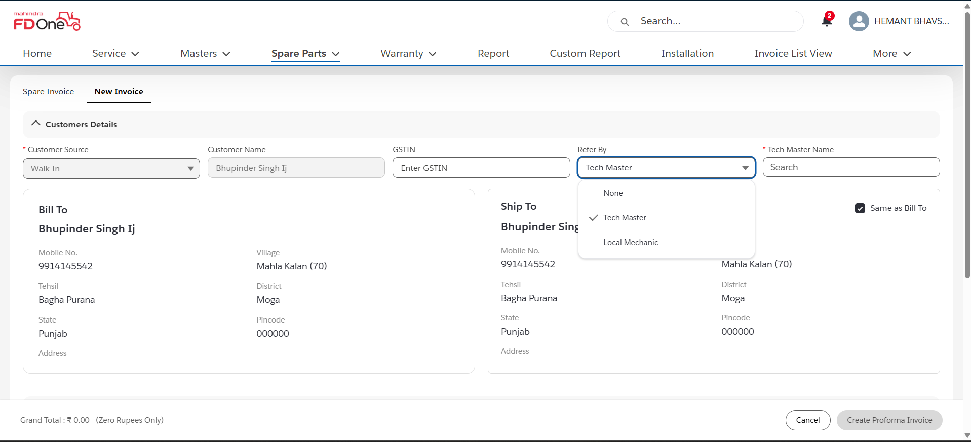

- Under Add Items search with relevant Part number for which Invoice needs to be created
- Once Parts are selected click on Create Proforma Invoice

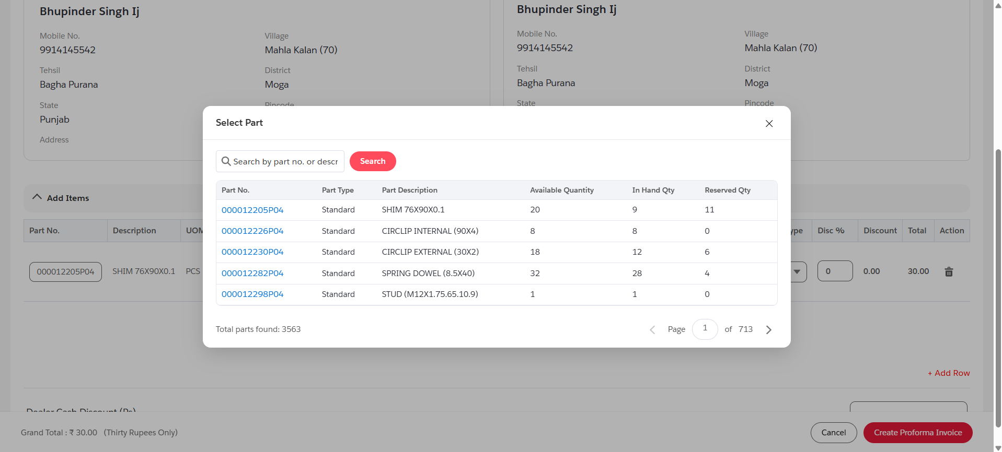

Proforma Invoice gets generated user will have 3 options on the top of the screen at right side To download the Proforma Invoice , Edit the proforma Invoice and if user wants to create Final Invoice click on Create Final Invoice Button
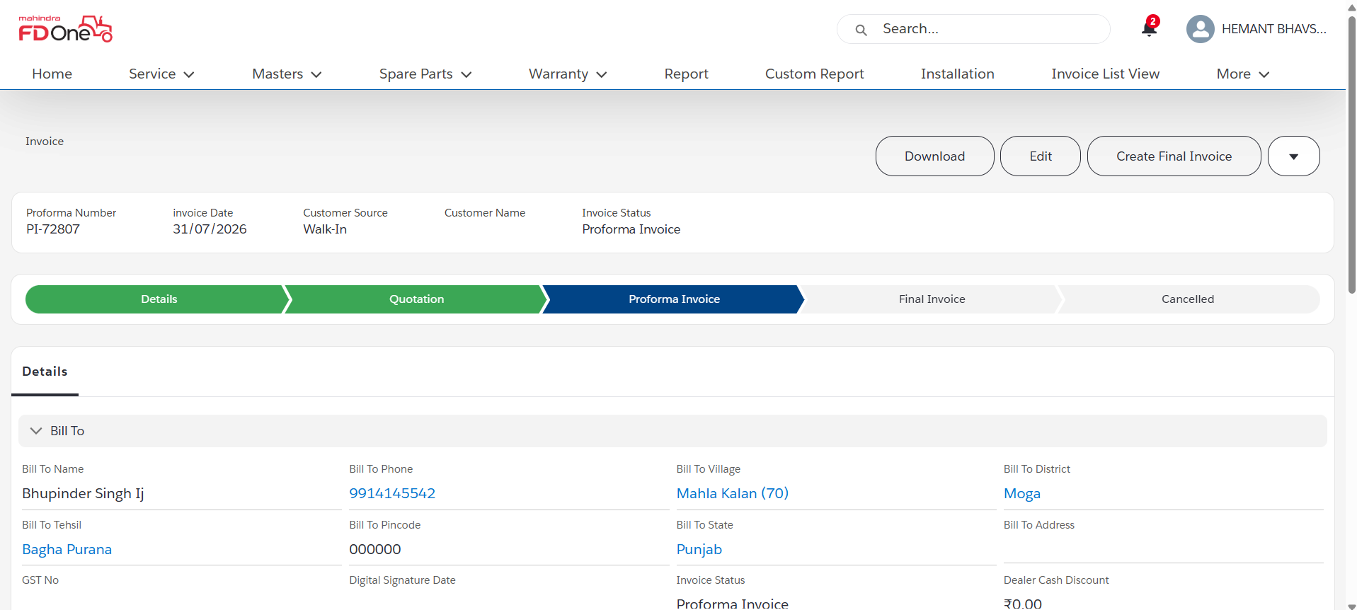

Total Parts Amount Summary is displayed at end of the page
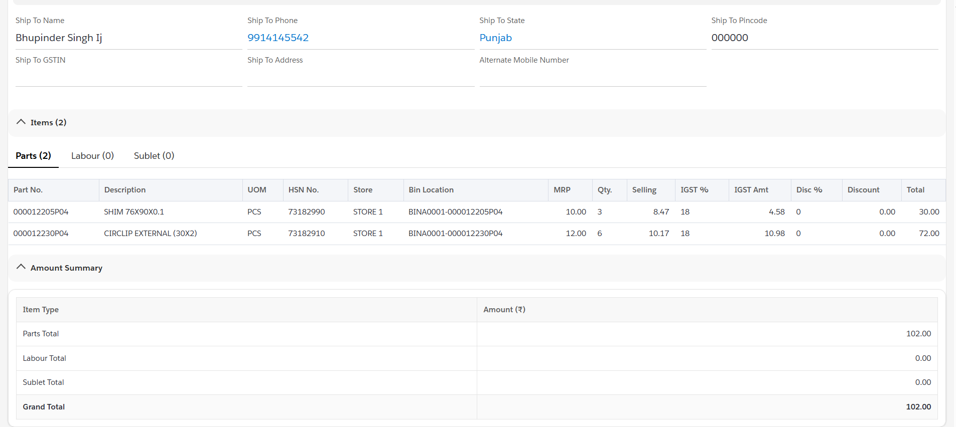
- Once User clicks on Create Final Invoice Button below screen pops-up for settlement method options
- Available options are Cash or Credit
- Select the payment mode, Type of the Cash, Reference Number and the Amount
- Click on submit button to generate the Final Invoice

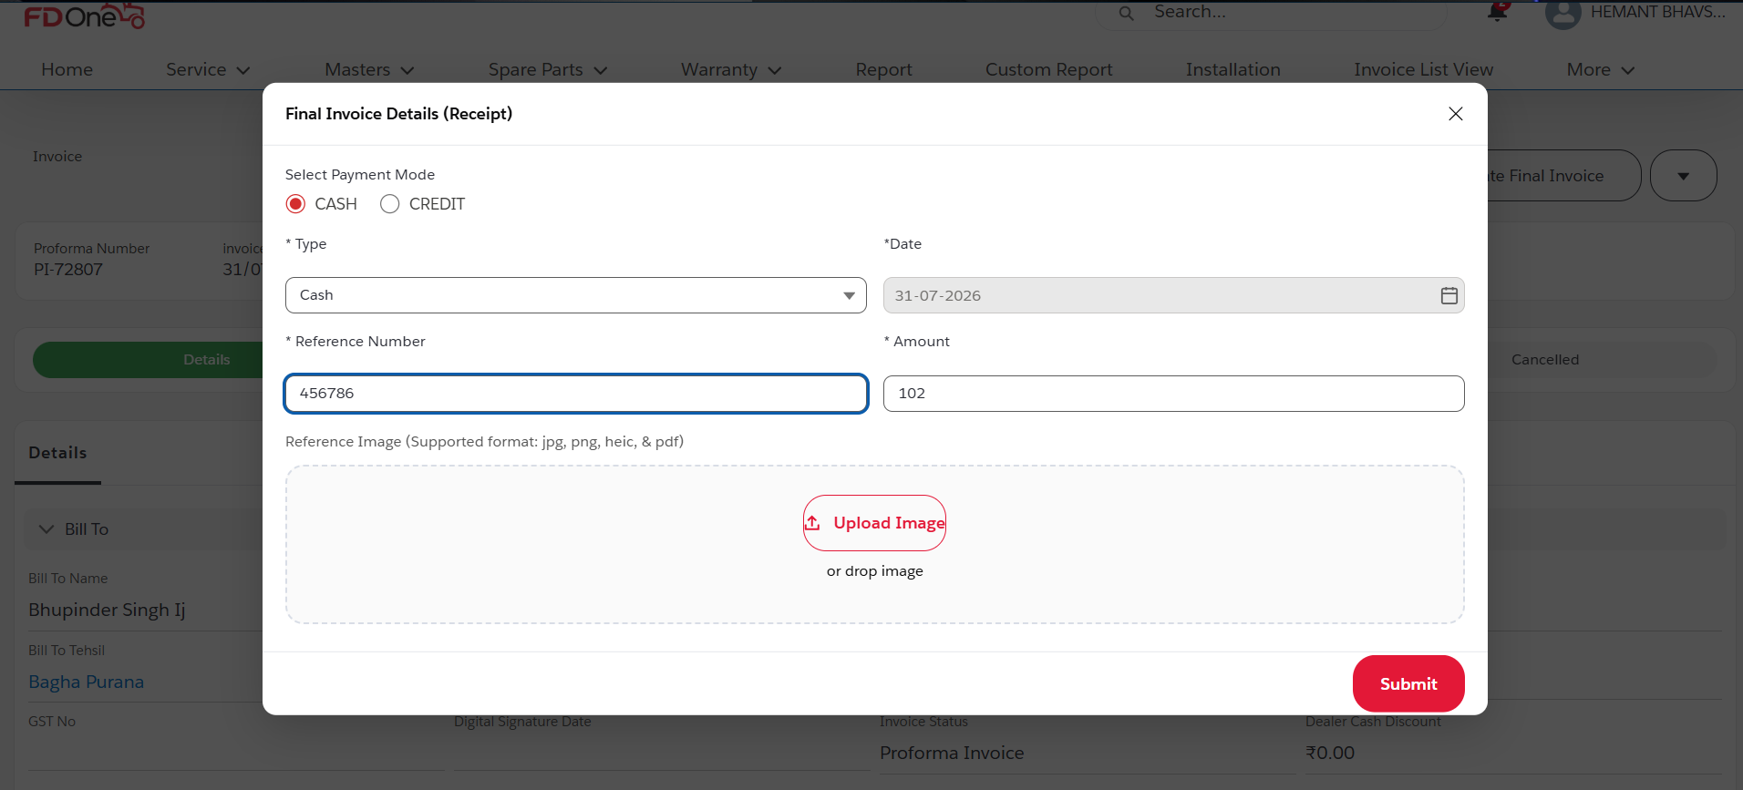

Detailed page of Invoice gets displayed and user can have option to download the Invoice.

