Standard Operating Procedure (SOP)
Dealer Visit Report (DVR)

Login into FD-One Application to create DVR (Dealer visit Report)
Any M&M user can create DVR
Search with Dealer Visit Report and a list view of DVR will get displayed as given below
To Create a new DVR , click on Create DVR Button which is in top right side

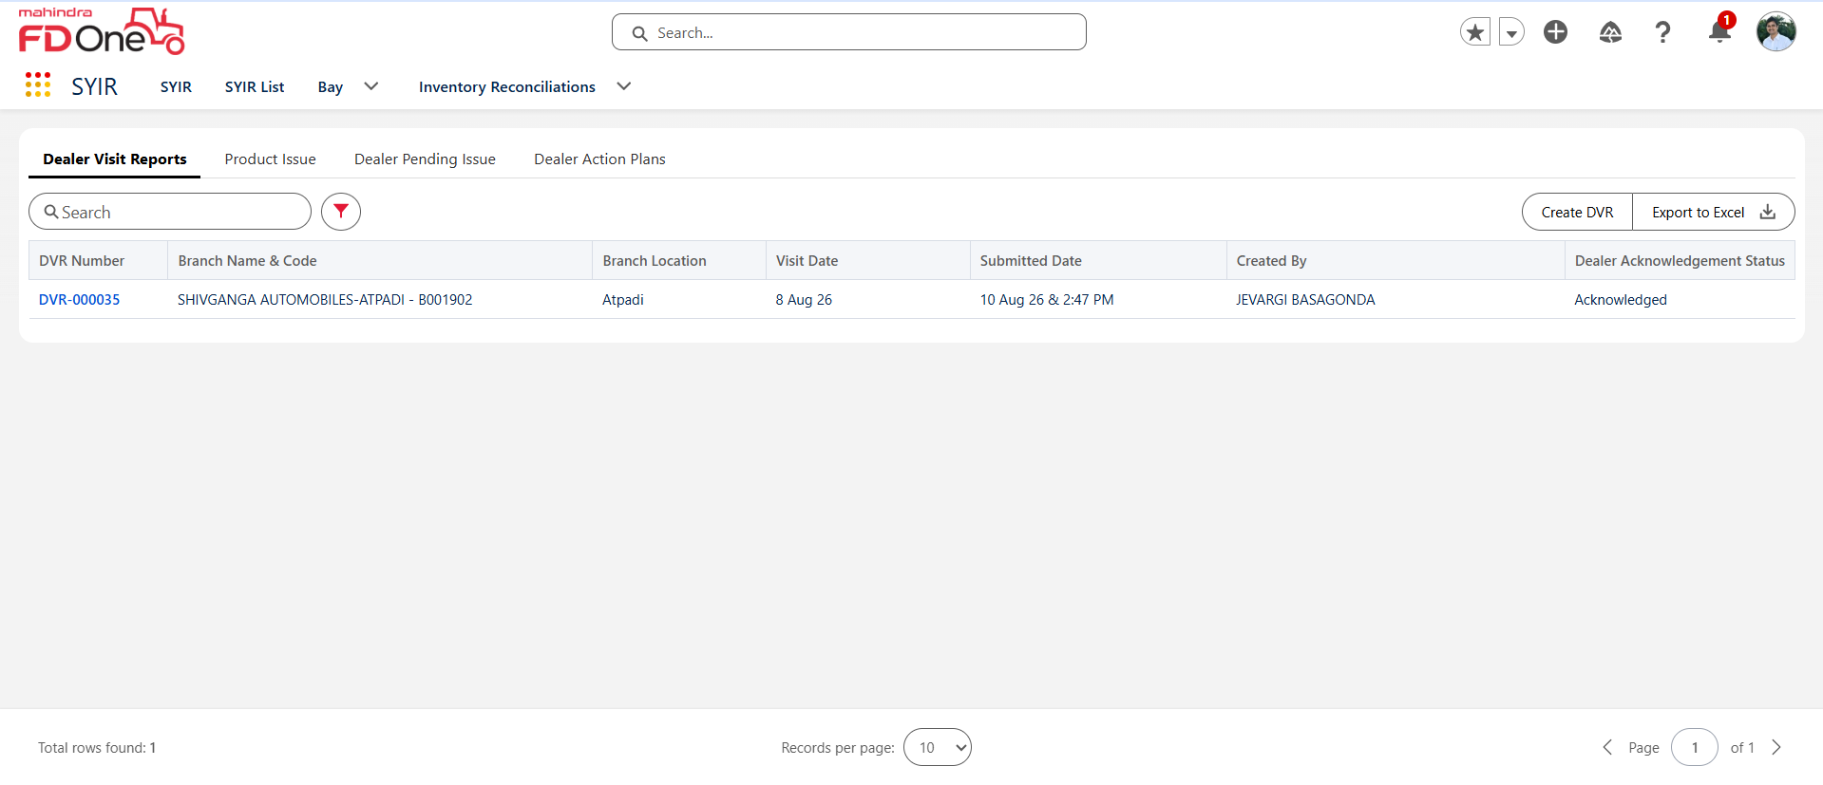

A detailed page gets opened for which dealer user wants to create a DVR
Select the Dealer Code and click on blue text of dealer code
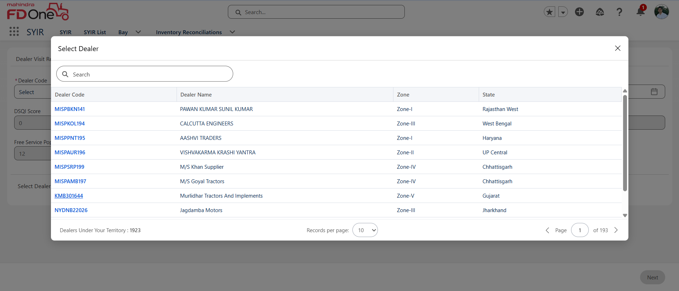
Select the branch code for which particular branch the report needs to be created
Select dealer visit date

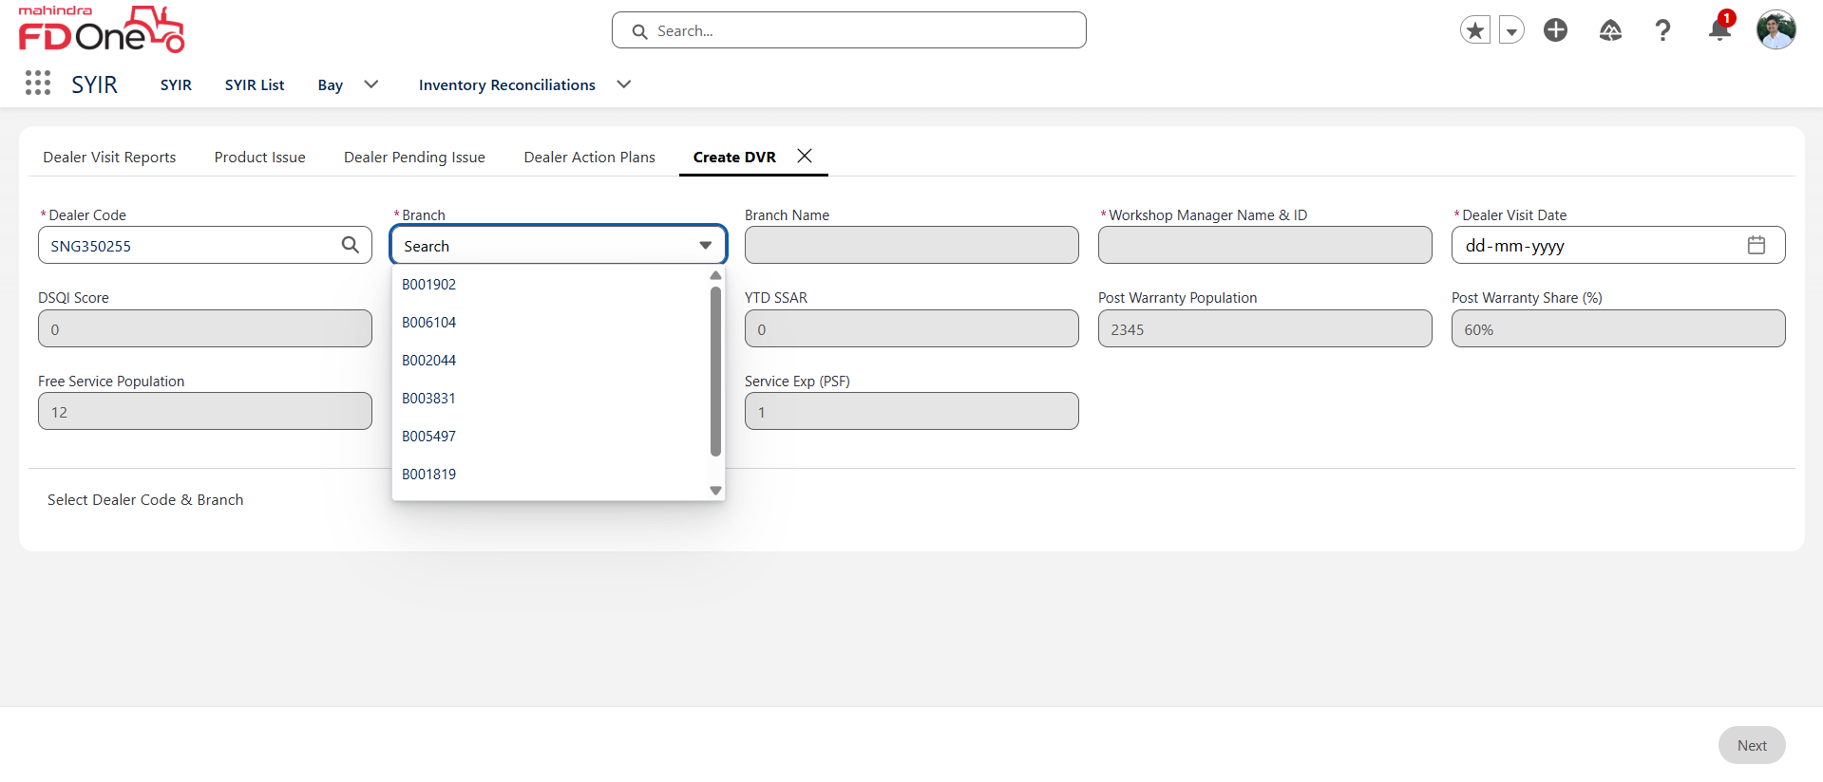
Below Tabs are listed as Workshop Hygiene where all the parameter has to be updated under Action radio button as Available or Not available
If Not available is selected then Remarks are mandatory to enter
Click on Next button

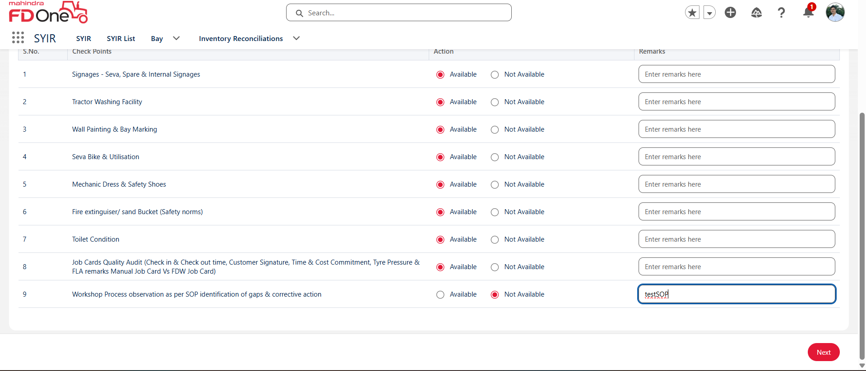

Action to be updated for Parameters under Customer Experience as well
Once updated click on next
User can skip if it’s not needed to update the Action

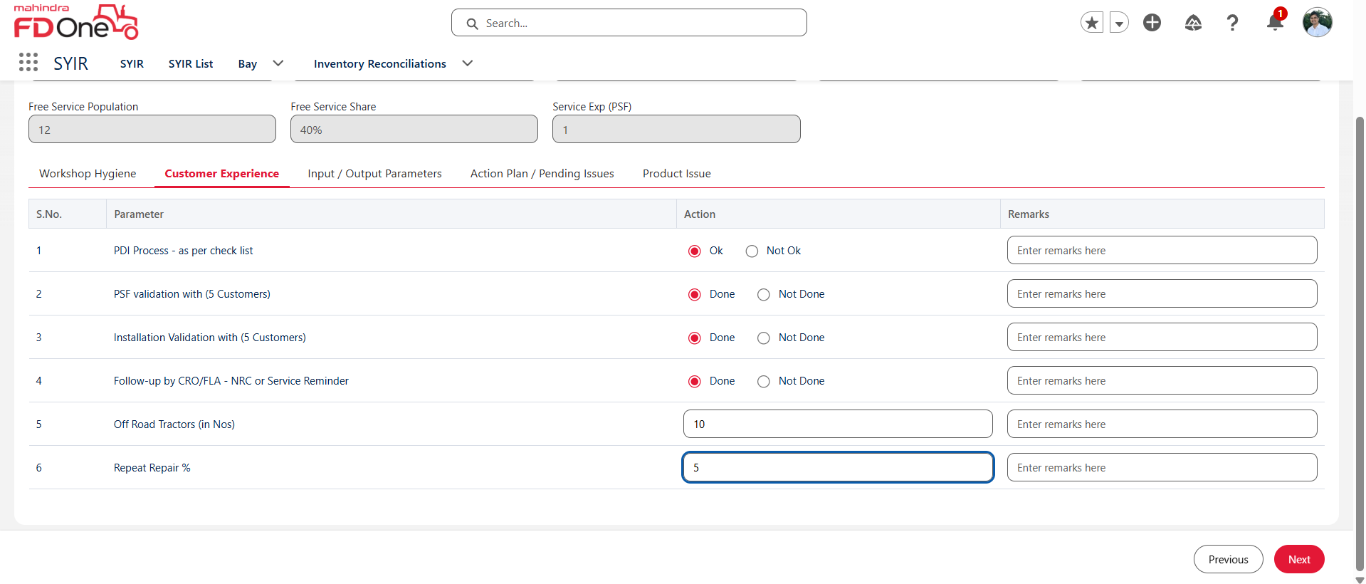
Select the Responsibility if any pending issue are present for that dealer and target date is mandatory

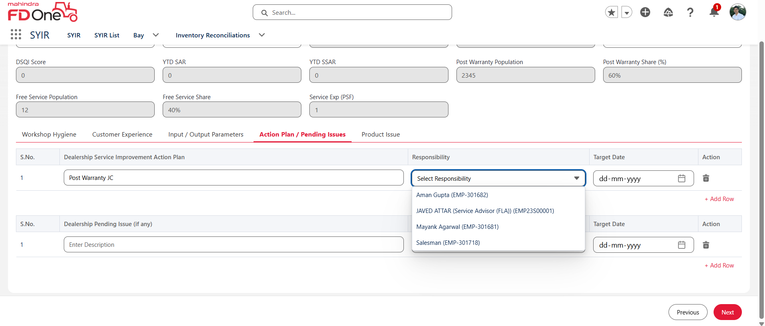

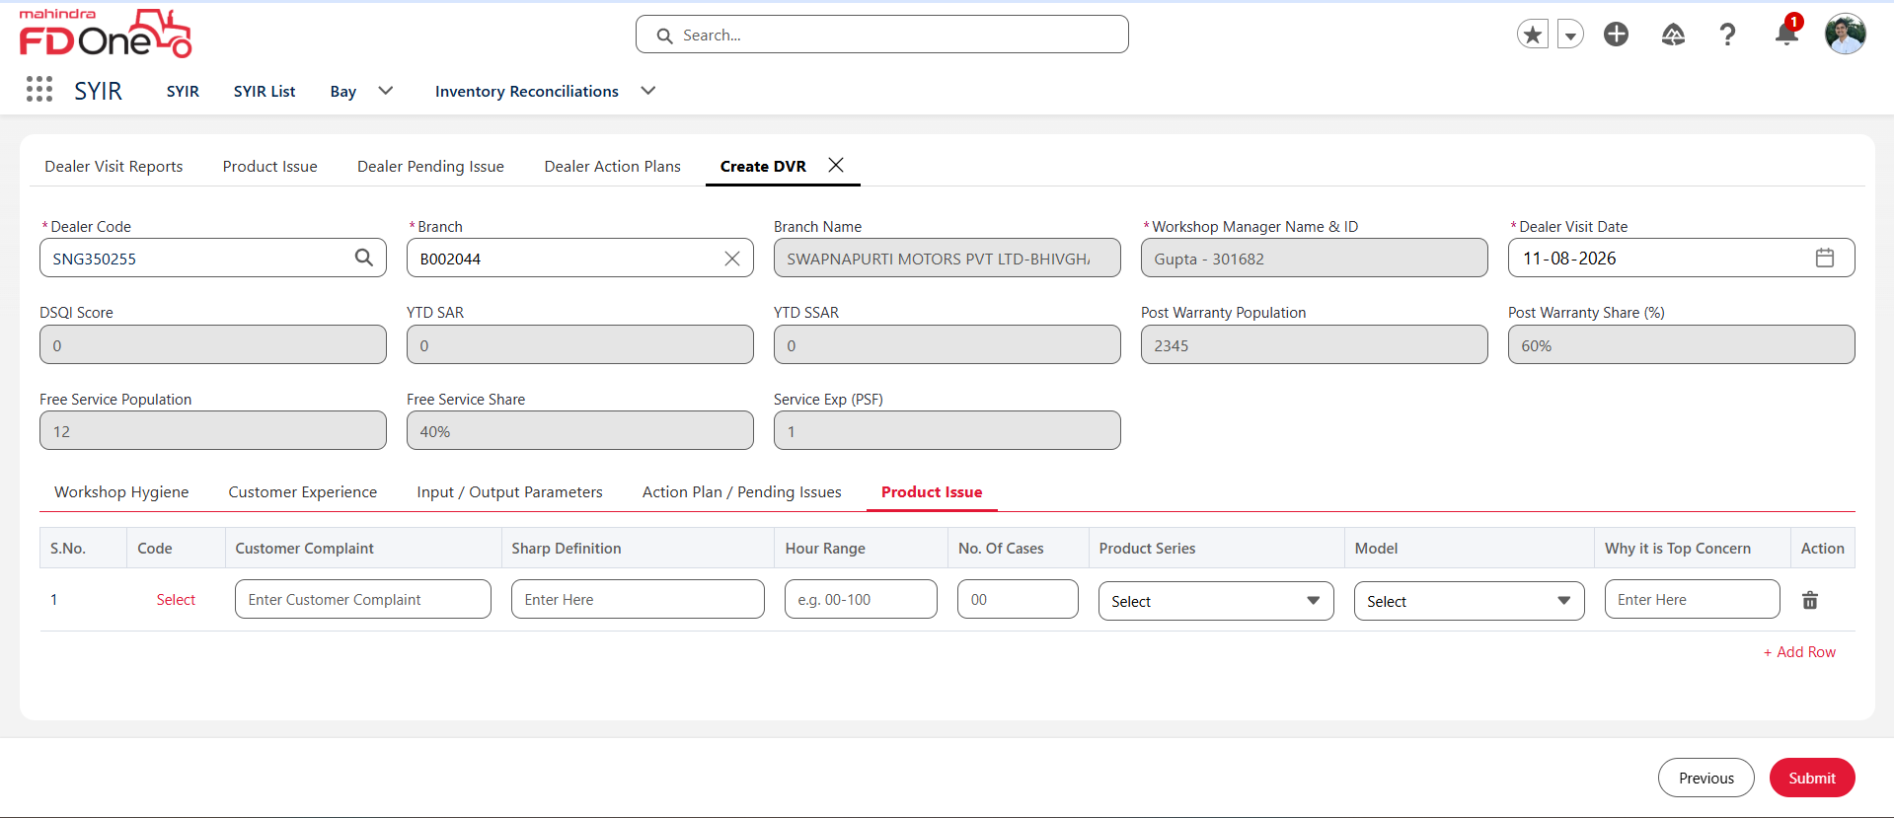
Once all the Actions are updated click on submit action button and confirm to save the DVR
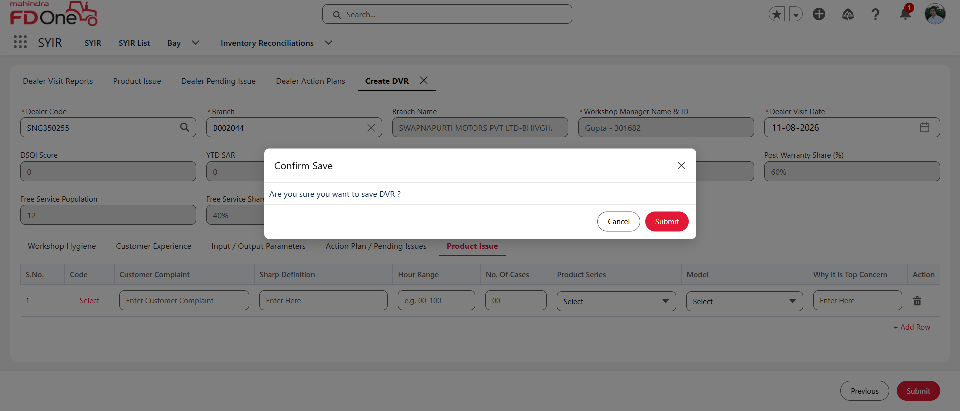
A detailed page of DVR gets loaded to view

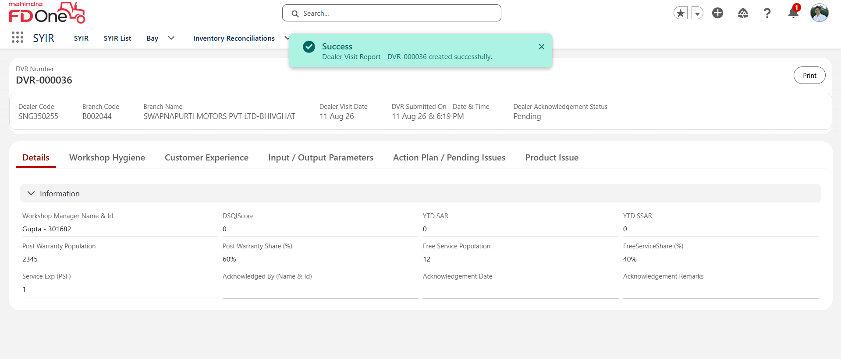

By clicking on print button a detailed report of DVR can be downloaded.

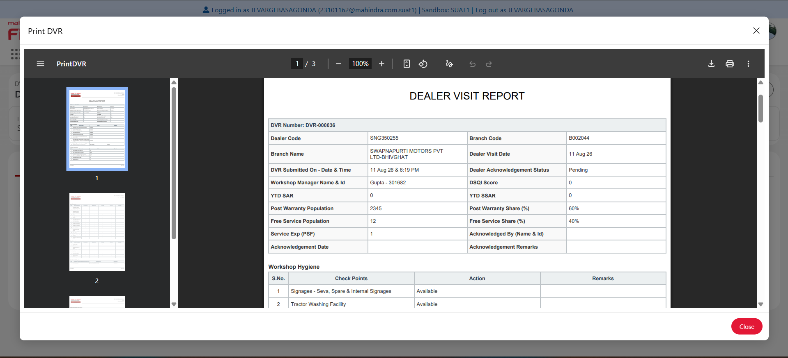
Status of DVR is under Pending as the submitted Report is pending with dealer to acknowledge it.

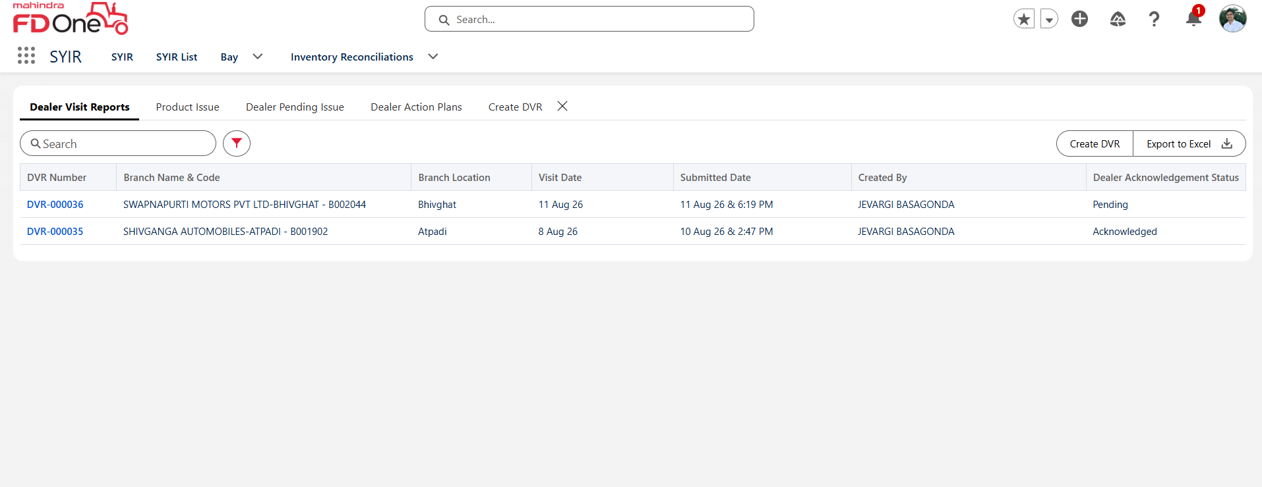

If any actions are pending under Dealer Action Plan user can update the status as close enter the Remarks and submit.

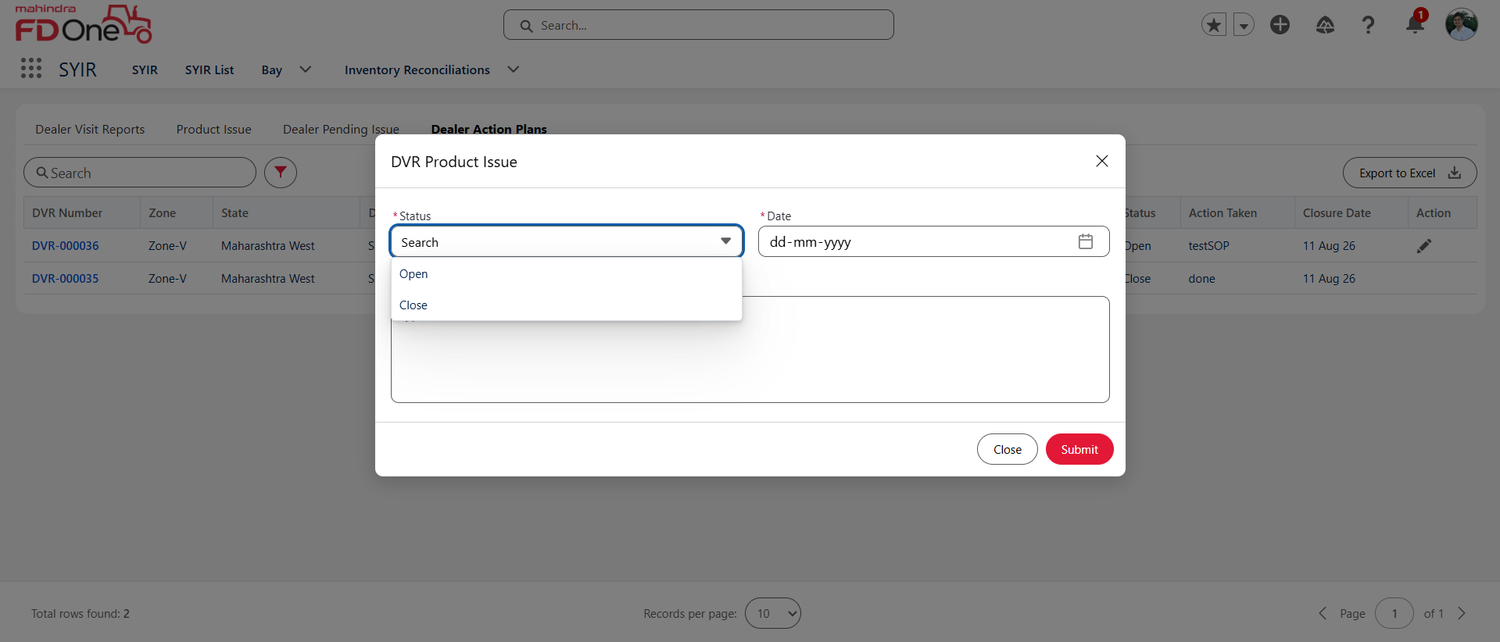

If any actions are pending under Dealer Pending Isser user can update the status as close enter the Remarks and submit.

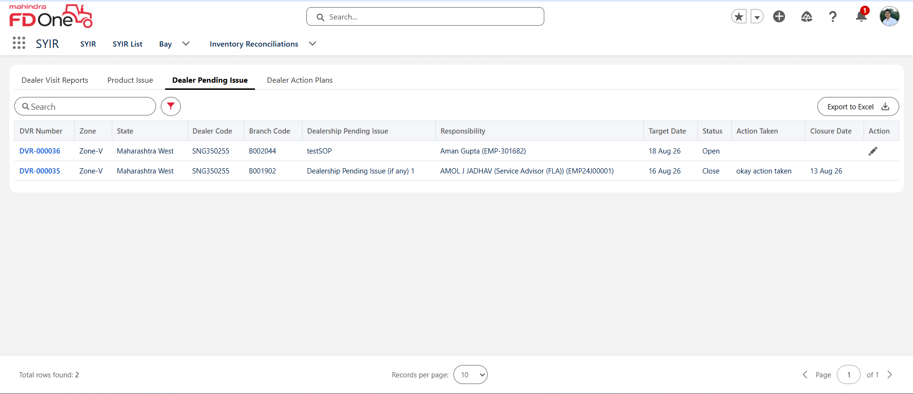

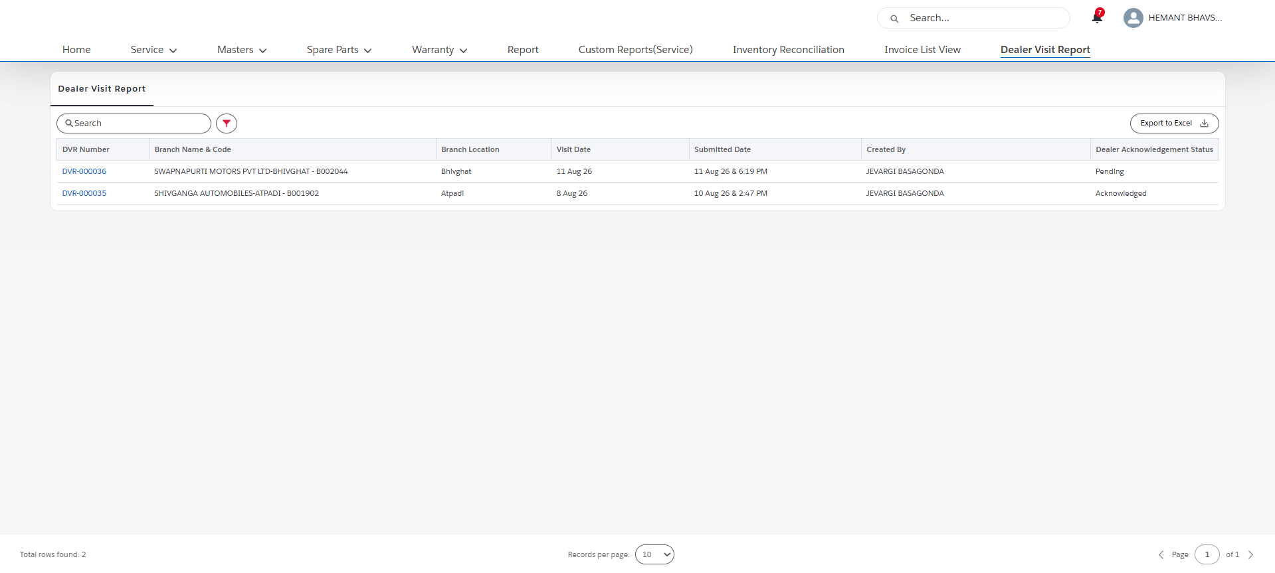
Below is the screen of Dealer CEO where DVR needs to be acknowledged
Dealer user can click on Acknowledge DVR Button which is on top right corner to Acknowledge the DVR
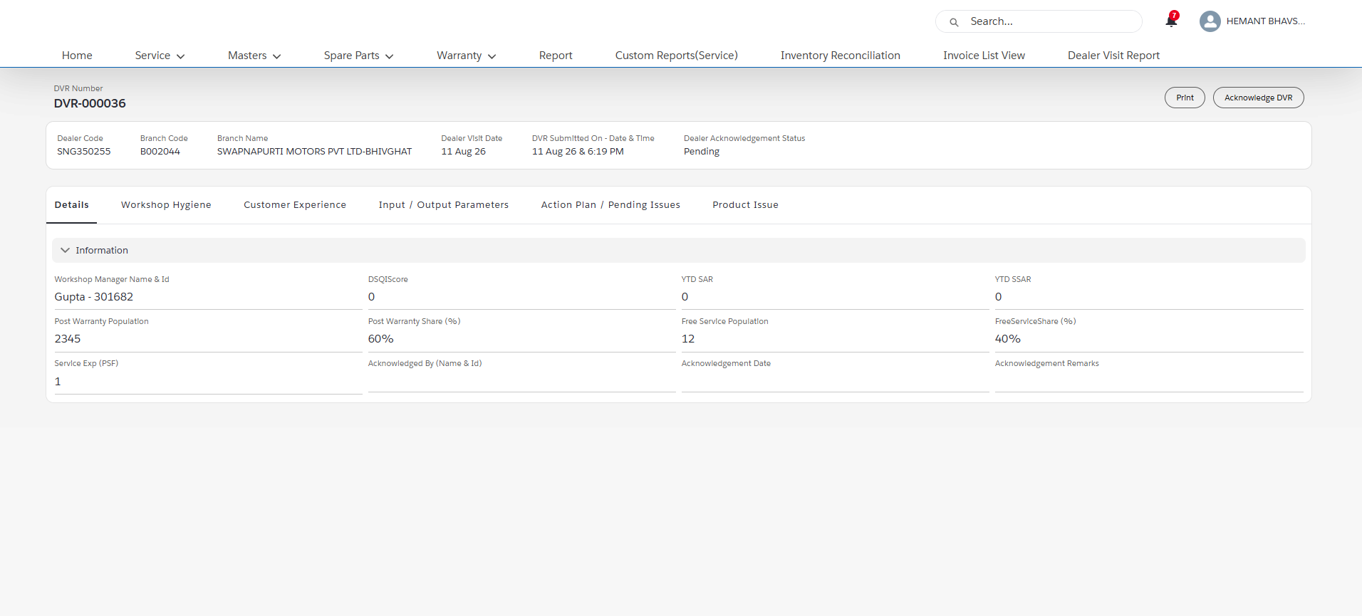

Once DVR is Acknowledged the status gets updated as Acknowledged.

